Website analysis:

My chosen industry is the world of advertising. And I have found this agency called The Bank – an advertising agency that represents many brands and many clients. Being an advertising agency, The Bank doesn’t have a specific target audience because; it accepts any brand and product to advertise. I will analyze its biggest clients from their own websites. I will use a 360 integrated, marketing and media plan to understand the conventional consumers needs for that product.

Peroni: http://www.peroniitaly.com/peroni-nastro-azzurro-0
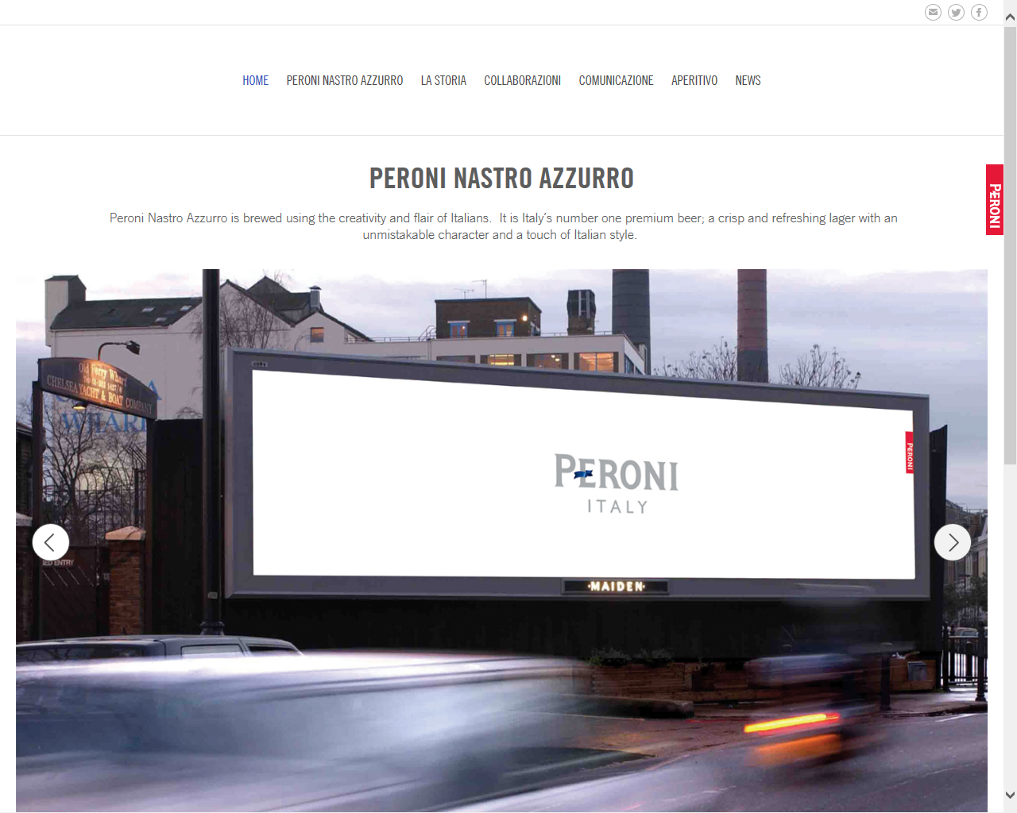
1) The target audience for this website is 25-35, unisex urbanites. Urbanites are young professional city dwellers with disposable income. Peroni Nastro Azzurro is classed as a global, premium brand; therefore it is targeted to audiences in over 100 countries around the world to those with professional, social status (middle class). The conventional consumer is attracted to and aspires to the concept of Italian style. In todays consumerist world where fashion and style are badges of status and confirmation of our externalized sense of self, Italian style is the essence of the conventional consumer living the good life, connoting that Italian style appears in the pyramid of Maslow’s hierarchy of needs under the self – esteem title. Italian style is famous around The World for its unique quality, craftsmanship and elegance. The ideology behind this brand is “No one does it with more style than the Italians… Prada Italy, Armani Italy, why not Peroni Italy.”
Peroni Italy is the brand’s ‘Signature’ used in every campaign and in every communication, it is born out of the idea of taking Italian fashion cues and applying them to a beer. This is represented on the homepage of Peroni by the clean white space signifying simplicity, design and style. The Peroni red tag on the homepage is borrowed equity from the Italian fashion brand Prada. Prada’s red tag connotes Italian fashion, style and perfection through fifty years of being a high style brand, Peroni’s red tag acts and behaves in a similar way to Prada’s; therefore the same values and quality’s that consumers have for Prada are triggered automatically by Peroni’s red tag. The first paragraph on the homepage talks of the creativity and flair of Italians. “Peroni Nastro Azzurro is brewed using the creativity and flair of Italians. It is Italy’s number one premium beer; a crisp and refreshing lager with an unmistakable character and a touch of Italian style.” This appeals to the Peroni’s demographic through its use of language; its use of language connotes to the target audience that Peroni Nastro Azzurro is a premium quality beer. The Peroni font is sans serif signifying it’s clean, simple and designer. In the top navigation bar the sections of the website are all written in Italian representing a sense of Italy with true authenticity signifying it as an authentic Italian brand. The front page is very simple and uncluttered, again signifying and giving hints from other global Italian fashion houses - such as Prada and Armani.

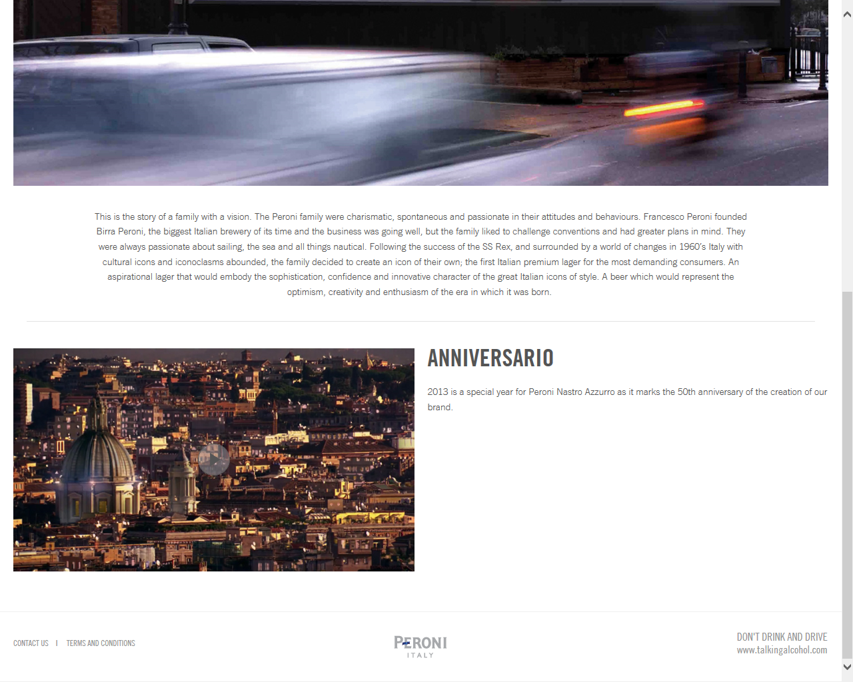
2) The front page immediately grabs this particular audience’s attention by creating a homepage that looks like no other beer homepage, but rather looks more like a homepage of Italian style brands. Clean, simple, stylish and well designed it is unconventional, therefore it is immediately attractive. It is attractive to those that appreciate clean, simple, and stylish and the unconventional. These people are usually urbanites n cities such as: London, New York and Birling. They are usually early adopters (adopt things early in society) and trendsetters. This demographic enjoy new, out of mainstream and stylish products. The use of a single image taken from a real in-situ advertising space represents a modern brand, cool and dynamic. Conventionally, normal advertising will always feature product visually; this ad however, creates intrigue by not connoting the product in any way visually or in words. For example: the target audience didn’t know it was a beer and couldn’t see it was a beer. Therefore, the modern and sophisticated consumer loved it straight away. This launch signifies Italian style like no other beer brand can possibly, authentically do. The idea of not showing the actual product is brave, confident and unusual signifying and creating mystery, intrigue and desire. This has never been done in the beer category in the history of adverting, making it one of the most break through pieces of communication in the last 30 years. This launch left audiences wondering and therefore wanting to know what this new product was connoting this new product is something different. Below this image is describing a short history of the brand created in the 60s by the Peroni family – a time when Rome was the centre of fashion and style. There is a deep desire within today’s consumers for brands that have and can demonstrate authenticity and a sense of place and being. This is due to a lack of belief in the last 20 years in brands that have no history, have no heritage and therefore no credibility or substance. This message communicated to the target audience connotes that Peroni is a beer with not only style but also history. This again connotes this is a true style brand. Also, at the bottom of the home page is a link to Peroni Nastro Azzurro’s 50th anniversary commercial, this represents the history of the brand. The inspiration, the creation and the celebration of the brand. The inspiration is taken from the success of the trans Atlantic cruise liner The SS Rex. The SS Rex won the Blue Riband (Nastro Azzurro or Blue Ribbon) for the fastest trans Atlantic crossing in 1933. Carlo Peroni and the Peroni family were keen sailors and this prize represented all that was good and optimistic about Italy. It was 30 years later in 1964 that Carlo Peroni created Peroni Nastro Azzurro connoting his respect and significance to Italy.

3) The generic conventions of beer websites are represented through imagery such as conventional consumer social occasions. Usually boys in the bar, boys on the beach, boys at the BBQ or boys with babes these are known as the 4 B’s. For example, Fosters for boys on the beach and Castle lager for boys at the BBQ. Also for example Stella for boys with babes. And finally for instance: Carlsberg with boys in the bar. These are the central ideologies of the genric beer advertising and because Peroni is an unconventional beer it chooses its own form of beer advertising and stays away from the conventional ‘4 B’s’ beer advertising.
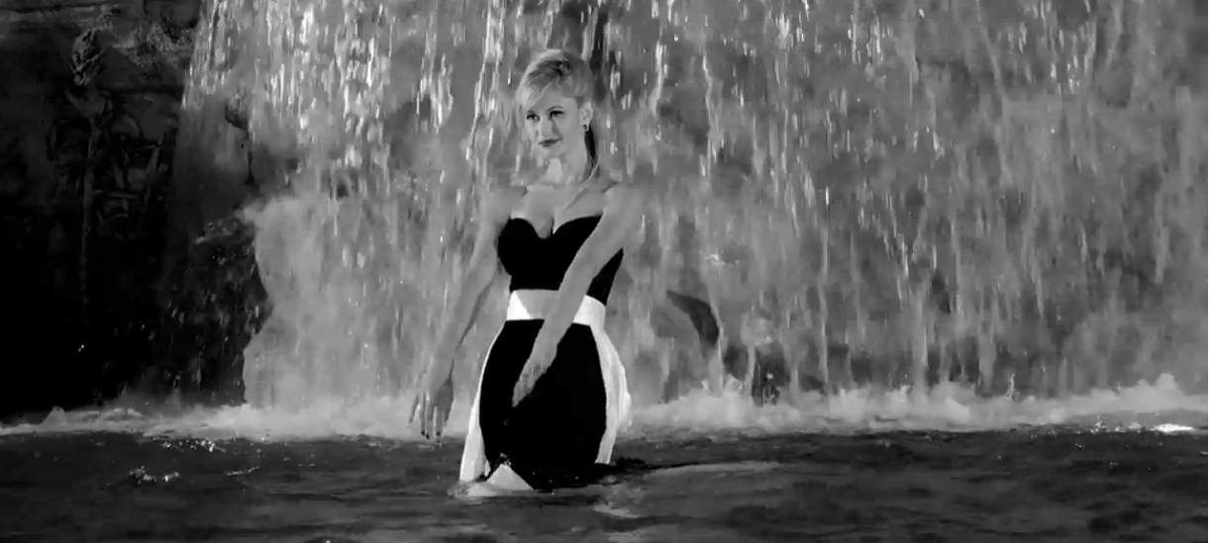
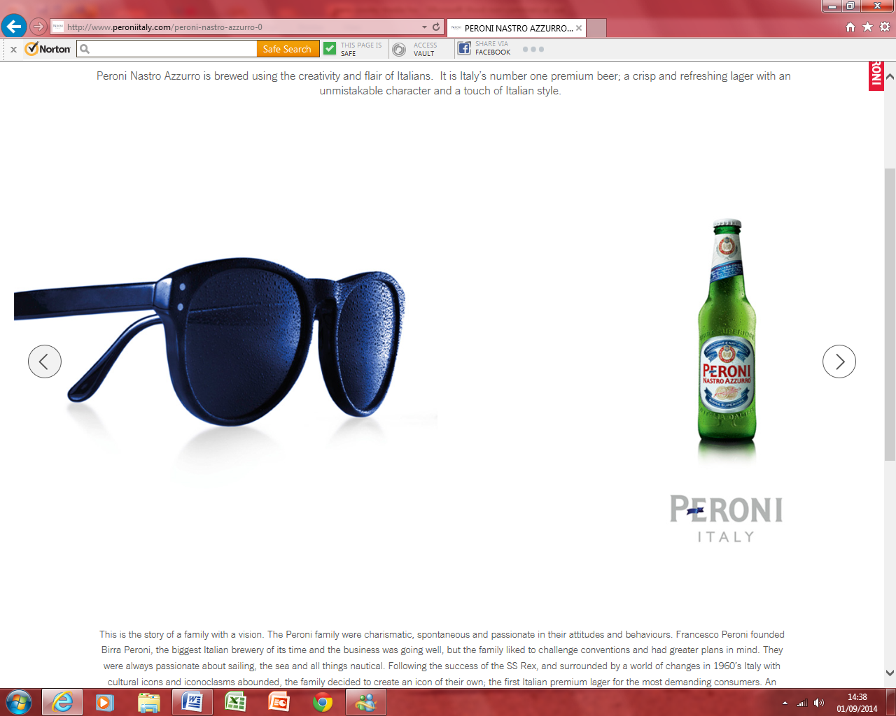
Peroni Nastro Azzurro sort to create a new beer that went against the stereotypical generic conventions of beer advertising. The homepage does not denote any idea of boys, beaches, BBQ’s, babes and bars. This homepage connotes style, modernism, design and unisex appeal. It does not represent lads out on the town, it signifies a cooler more sophisticated urbanite. This is achieved through multiple imagery as you scroll through the image bar starting off with the Peroni image ‘Signature’. The second image is of a simple pair of Italian fashion sunglasses denoting true Italian style. Placed to the right is a single bottle of Peroni Nastro Azzurro with the famous Peroni Italy lock up below. The sunglasses are iconic of Italian style. The bottle is borrowing the equity of this icon to signify its own iconic status as an Italian style brand. The relationship between the two is connoted by the light touch of “spritz” on each image – both images are cool and refreshing. The next image is of a famous Italian designer chair. This time the relationship between the two images is denoted through the use of the blue ribbon (Nastro Azzurro). The next image on the image bar is of an advert that pays homage to Federico Fellini’s classic 1960 film La Dolce Vita. The Trevi Fountain image is one of the most famous, cinematic scenes of all time. Peroni re-shot this scene in 2007 the first time anyone had been allowed to shoot in the Trevi Fountain since the great Fellini. The mis-en-scene represents through classic film noir cinematography a stolen moment of wild abandonment.

4) The marketing strategies that this brand uses to attract this target audience are:

Brave out of category strategic thinking connoting Peroni Nastro Azzurro as an Italian style brand. Creating aspiration in the consumer by representing Peroni as style in a bottle.

Collaborazioni / collaboration as part of its marketing strategy Peroni Nastro Azzurro has partnered with the Italian fashion brand Prada as the official supplier to the Luna Rossa challenge. As part of its marketing strategy, Peroni has also partnered with Eatilay, the premium Italian restaurant chain and it has created its own social occasion called Aperitivo. Aperitivo occurs after the working day between 5pm and 8pm consisting of a couple of Peroni’s and small amounts of bowl food (Tapas).

As part of the marketing strategy in the new section of the website there are many articles on the philosophy of fashion, design and art and many other aspirational views on life connoting Italian style.

As part of it marketing strategy Peroni Nastro Azzurro adopts a create, build and cascade model.

- Create desire in the consumers mind by launching only in premium hard to enter bars, advertise only in select cinemas and launch with a premium price with a premium image. Do this in select cosmopolitan areas only.
- Build your consumer base slowly over time by appealing to cool urbanites by appearing in select venues, cool publications creating experiential occasions. Build your outlets over time, creating long lasting brand loyalty and keeping a sustainable premium price.
- Cascade the product globally having created a sustainable loyal consumer base by investing in the right sponsorships, partnerships and collaborations. Enter countries/markets on a global scale through the cosmopolitan urbanite locations following a centralized/marketing model, guaranteeing consistency, reliability, sustainability and legacy. This ensures the creation of a global brand that can last for 100 years.

5) The navigation of the website is simple uncluttered, clear and precise. Images are kept to a minimum, words are concise and the designed using white space allows the eye to focus on clear points. This signifies the elegance and premium level of the brand. Conventionally, an elegant and premium product is kept simple. The audience get a sense of simplicity and style, connoting that Peroni is indeed style.
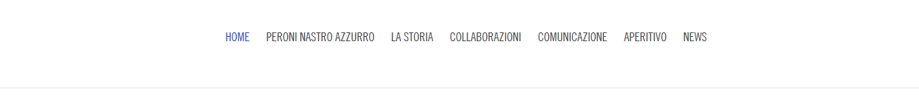

6) The front page immediately grabs this particular audience’s attention by creating a homepage that looks like no other beer homepage, but rather looks more like a homepage of Italian style brands. Clean, simple, stylish and well designed it is out of category, therefore it is immediately attractive. The use of a single image taken from a real in-situ advertising space represents a modern brand, cool and dynamic. This launch signifies Italian style like no other beer brand can possibly, authentically do. The idea of not showing the actual product is brave, confident and unusual signifying and creating mystery, intrigue and desire. This has never been done in the beer category in the history of adverting, making it one of the most break through pieces of communication in the last 30 years. This launch add left audiences wondering and therefore wanting to know what this new product was connoting this new product is something different. Below this image is a describing a short history of the brand created in the 60s by the Peroni family – a time when Rome was the center of fashion style. This again connotes this is a true style brand. Also, at the bottom of the home page is a link to Peroni Nastro Azzurro’s 50th anniversary commercial, this represents the history of the brand. The inspiration, the creation and the celebration. The inspiration is taken from the success of the trans Atlantic cruise liner the SS Rex. The SS Rex won the blue riband (Nastro Azzurro or Blue Ribbon) for the fastest trans Atlantic crossing in 1933. Carlo Peroni and the Peroni family were keen sailors and this prize represented all that was good and optimistic about Italy. It was 30 years later in 1964 that Carlo Peroni created Peroni Nastro Azzurro connoting his respect and significance to Italy.

7) The website has links to social networking sites like Facebook, Twitter and Instagram. The Facebook page newsfeed has many interesting conversations including the highlighting of experiential activations including the House of Peroni and Picturehouse Cinema. The twitter page has 3000 followers that talk about fashion, design, photography, food and film - making. It signifies that Peroni is a modern brand that is in the social network psyche as a relevant thought leadership brand. 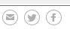

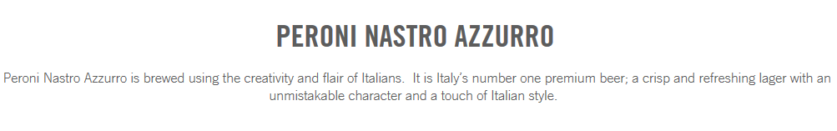
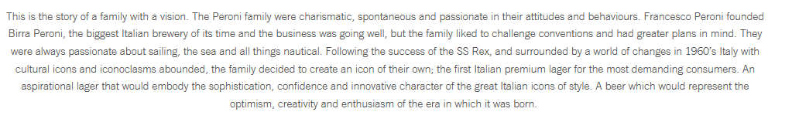
8) The text on the homepage targets the audience by delivering the promise of the brand with authentic substantiated proof points of the brands history that represent it’s Italian style credentials. The first paragraph talks about the creativity and flair of the Italians signifying craftsmanship, artistry and skill that the Italians are known for world-wide in many other industry’s including fashion with the likes of Armani. Also including the car industry with Ferrari, also including the design industry such as Alessi. This paragraph talks about ‘premium’ signifying the desire in the targeted consumer for products that are high end. Also this paragraph mentions Italian style connoting, the idea that no one does style better than the Italians whether that applies to clothes, cars, kitchen wear or beer. The second paragraph talks about the vision of the brand based on its history and its foundations and its birthplace by sighting the 1960’s as its time of birth and Rome and its place of birth, Peroni relies on the historical significance of these two elements, 60’s Rome was a time and a place that attracted the world’s elite. The famous and the fabulous included such stylish icons as: Audrey Hepburn, Bridget Bardot and Elizabeth Taylor. The very word Paparazzi was invented based on a character called Paparazzo from the film La Dolce Vita. He was a photographer of the starlets in Rome in the 60’s. Paparazzi is a modern conventional term that represents photographers of the famous. All of this creates an aspirational world in the consumers mind connoting style, sophistication and fashion, whilst applying this to the Peroni product.

9) The generic conventions of beer websites are represented through imagery such as conventional consumer social occasions. Usually boys in the bar, boys on the beach, boys at the BBQ or boys with babes these are known as the 4 B’s. For example, Fosters for boys on the beach. For instance: Castle larger for boys at the BBQ. Also for example Stella for boys with babes. And finally for instance: Carlsberg with boys in the bar.
Peroni nastro azzuro sort to create a new beer that went against the stereotypical generic conventions of beer advertising. The homepage does not denote any idea of boys, beaches, BBQ’s, babes and bars. This homepage connotes style, modernism, design and unisex appeal. It does not represent lads out on the town, it signifies a cooler more sophisticated urbanite. This is achieved through multiple imagery as you scroll through the image bar starting off with the Peroni imagery signature. The second image is of a simple pair of Italian fashion sunglasses denoting true Italian style. Placed to the right is a single bottle of Peroni Nastro Azzurro with the famous Peroni Italy lock up below. The sunglasses are iconic of Italian style. The bottle is borrowing the equity of this icon to signify its own iconic status as an Italian style brand. The relationship between the two is connoted by the light touch of “spritz” on each image. The next image is of a famous Italian designer chair. This time the relationship between the two images is denoted through the use of the blue ribbon (Nastro Azzurro). The next image on the image bar is of an advert that pays homage to Federico Fellini’s classic 1960 film La Dolce Vita. The Trevi Fountain image is one of the most famous, cinematic scenes of all time. Peroni re-shot this scene in 2007 the first time anyone had been allowed to shoot in the Trevi Fountain since the great Fellini. The mis-en-scene represents through classic film noir cinematography a stolen moment of wild abandonment.

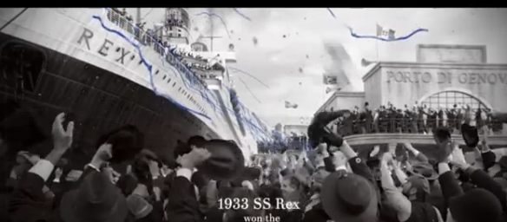
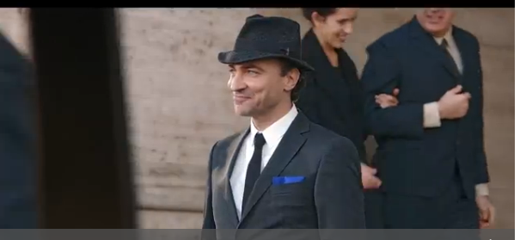
10) The link on the homepage is a cinema commercial that denotes the history of the brand, it is a celebration of 50 years. The ad starts in the 1930’s with a ship called the SS Rex winning the Blue Riband for crossing the trans Atlantic in the quickest time. The audience see Carlo Peroni as a young man getting inspiration from the blue ribbons that are thrown from the deck of the ship. This inspiration is translated 30 years later in 1964 when Carlo Peroni invents a beer called Peroni Nastro Azzurro (Peroni Blue Ribbon), during this section of the commercial the audience is immersed in a world of 60’s Italian style.

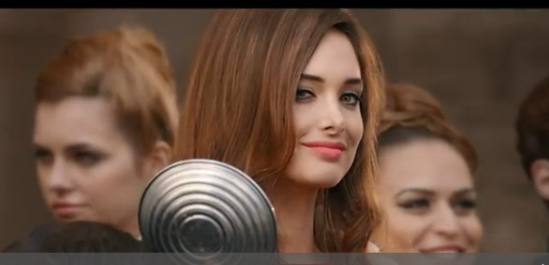

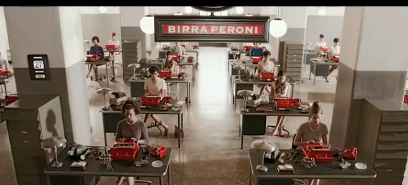
The audience sees a film starlet being chased by Paparazzi in the Via Veneto (The Sloane street of Rome) the audience sees Carlo admiring the starlet from a far connoting his admiration for all things of beauty. Carlo then arrives at the brewery HQ. This scene represents the “Madmen” genre, a time of cool, hip attitude to life. The ad then cuts to a sailor girl being photographed for the original launch poster of the 1960’s. The audience ends on a roof top scene of the young, cool and beautiful with Rome as the backdrop – the ad can’t help but create an aspirational world in the audience’s mind of a life style that is sophisticated, stylish and something every cool urbanite would want to be apart of. There are two pieces of music; the first piece is composed by Ennio Morricone -the most famous film soundtrack composer of all time. He composed films such as: The Mission, The Good the Bad and the Ugly and Once upon a time in America. The first 12 seconds in the ad is a track called Poverty taken from the film Once upon a time in America, this connotes in the Peroni ad a time of economic hardship post World War 2. A time of hardship in Italy that gave greater national significance to the winning by the SS Rex of the Blue Riband than if it were a different time. Ennio Morricone himself was born in the 1930’s in Rome, this gives the commercial fantastic authentic credentials of being a true and relevant Italian brand. After 12 seconds there is a transition as we are transported to 1960’s Rome the music changes signifying the transition to another time. The second soundtrack is by Sandi Shaw called ‘Always something there to remind me’ , it is upbeat and connotes a 60’s lifestyle when popular music was emerging, life was more optimistic and when some of the great Italian brands that we know today were created such as: Prada, Valentino, Pucci and Peroni. The voice over that features on the pack shot at the end frame is a sexy girl, she says “Peroni Nastro Azzurro Italy” her voice connotes a world of fashion, fame and fortune.
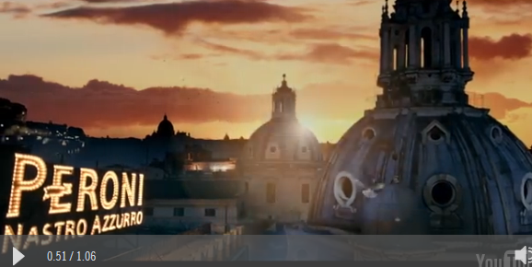
Subsequent page:

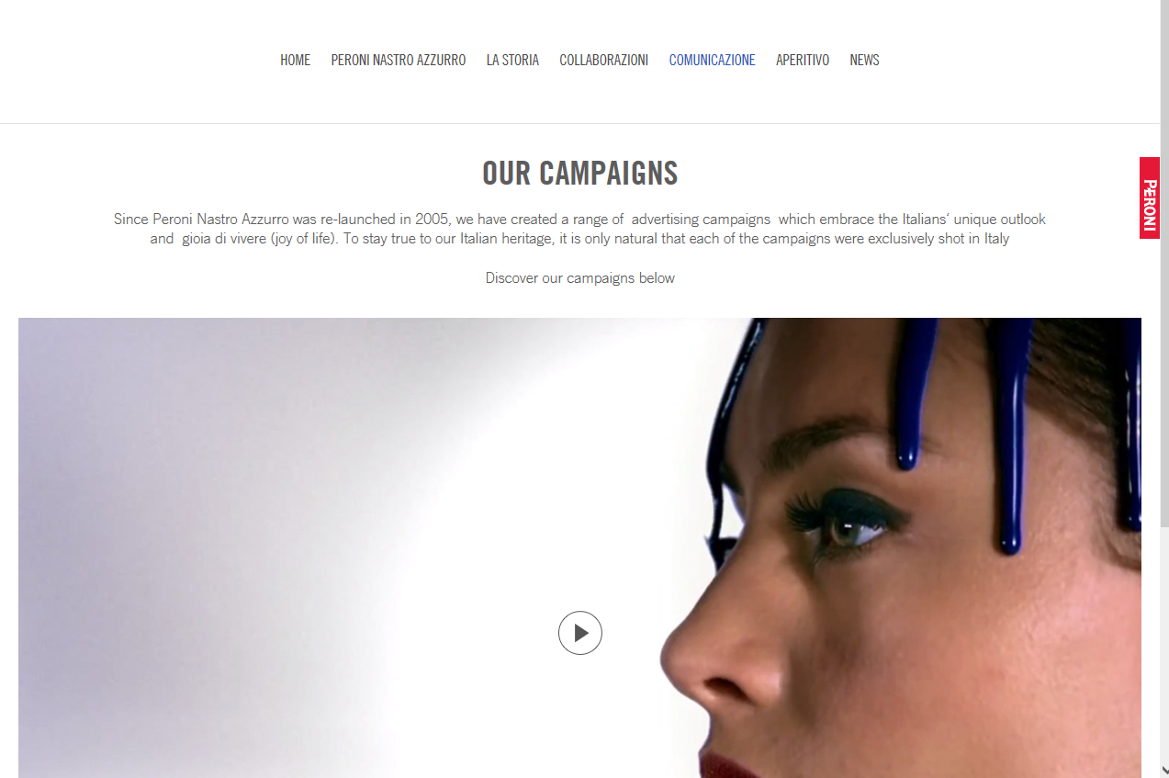
1) This page has been included in the website because it represents multiple advertising campaigns for Peroni Nastro Azzurro. The purpose of the campaigns are to communicate the unique Italian outlook on life. These campaigns whilst all individual all have key similarities. They deliver on the brand promise of “when it comes to style, no one does it better then the Italians” The consumer is immersed in a world of Italian style that create aspirations in the consumers mind to be part of this world. Each campaign connotes the idea that by drinking Peroni Nastro Azzurro the audience is part of this world. The page gives a rich and deep experience of Peroni’s brand essence. The ad’s themselves are of the highest cinematic quality; the music, the narrative and the art direction are beautiful and premium signifying these same qualities in the Peroni product. The campaigns page is proof of Peroni’s credentials of being an icon of Italian style. 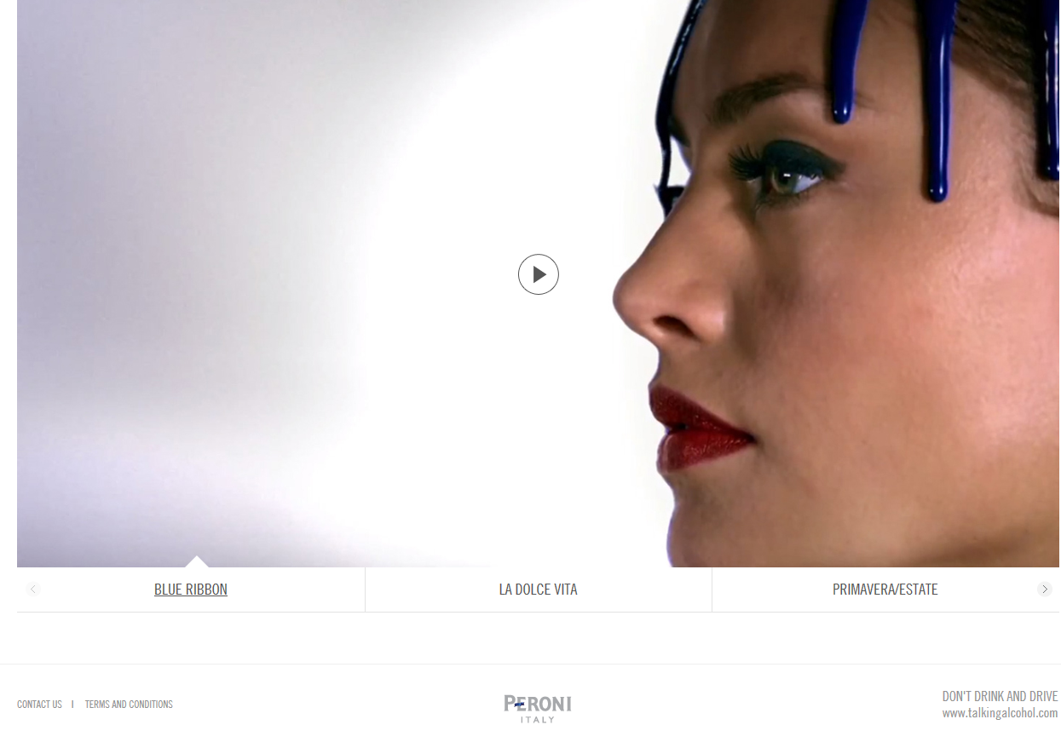

2) The importance of this page to engage and prolong the audience’s interest is the fact that the campaigns of the adverts are highly engaging and entertaining, the film quality and the story telling are what keeps the audiences attention. The casting, art direction, music and locations are so wonderful that people cannot help but want to keep watching. These ads also connote the intrinsic quality of the product. The beer is crisp and intensely refreshing, it does not have a bitter aftertaste; rather Peroni has a light fresh quality whilst having a 5.1 ABV. All of the ads are equally as fresh, crisp and powerful.
Because each campaign is different, this prolongs the audience’s interest. The first ad is the story of the blue ribbon (Nastro Azzurro). The blue ribbon represented by blue paint that travels and hits a series of recognized Italian iconic images, from the grill of an Alpha Romeo to the shade of an Arc lamp. The paint then runs down the side of a beautiful models face connoting that Peroni belongs in the high glamour world of fashion. The paint itself becomes and blue ribbon that then wraps itself onto the bottles label and becomes the labels longstanding design.

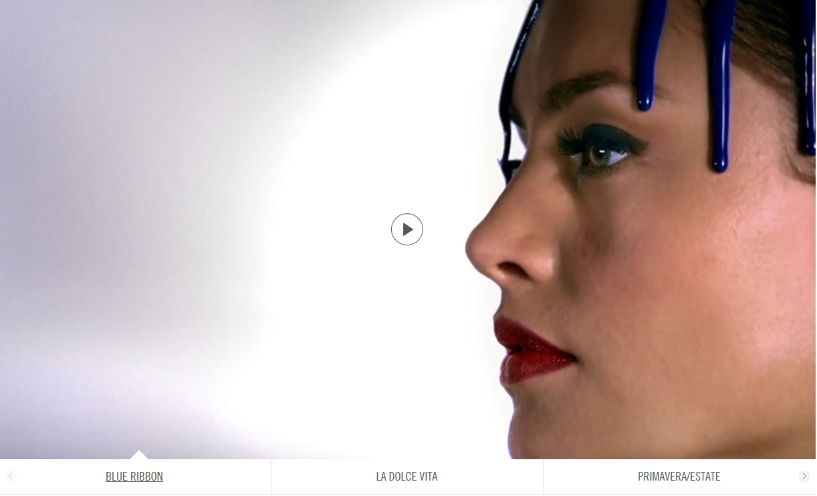
3) The girl with blue paint is obviously from the world of fashion. The art direction connotes that this could be Prada or Armani. The blue paint that runs down her face is a representation of the brand; Peroni Nastro Azzurro is blue ribbon. The quirky nature of the art direction elevates Peroni Nastro Azzurro out of the conventional beer category and creates a category of its own. The busiest place on the planet is is the human brain, advertisers fight for a moments attention from this global mind space; everyday people are exposed to thousands of messages only few will stick, only a few will be remembered, only a few will be talked about and only a few will result in financial successes. By creating a brand that is known for out of category thinking the brand is creating cut through communication. This is proven by the fact that Peroni Nastro Azzurro is the fastest selling premium beer today by value and by volume.

The mis-en-scene is taken from a commercial called La Dolce Vita (the sweet life). La Dolce Vita was a 1960 film directed by the great Federico Fellini – starring the famous starlet Anita Ekberg. This mis-en-scene is a homage to possibly one of the most famous cinematic images of all time. This image is of a model standing in the middle of the Trevi fountain in Rome in a full evening dress. It is counter intuitive a girl standing in a fountain. The fact that a girl in an evening dress, this is counter intuitive and unconventional. This image connotes a stolen moment of wild abandonment, the heady days and nights of Rome in the 60’s where and when coming across a film starlet in the fountain could be considered conventional. A time and a place where nothing was out of reach, where fame and fortune were in everyone’s reach. This image is iconic of that time post World War 2; Fellini captures the emergence of a new optimistic Italy with a bright future for all time in this mis-en-scene.

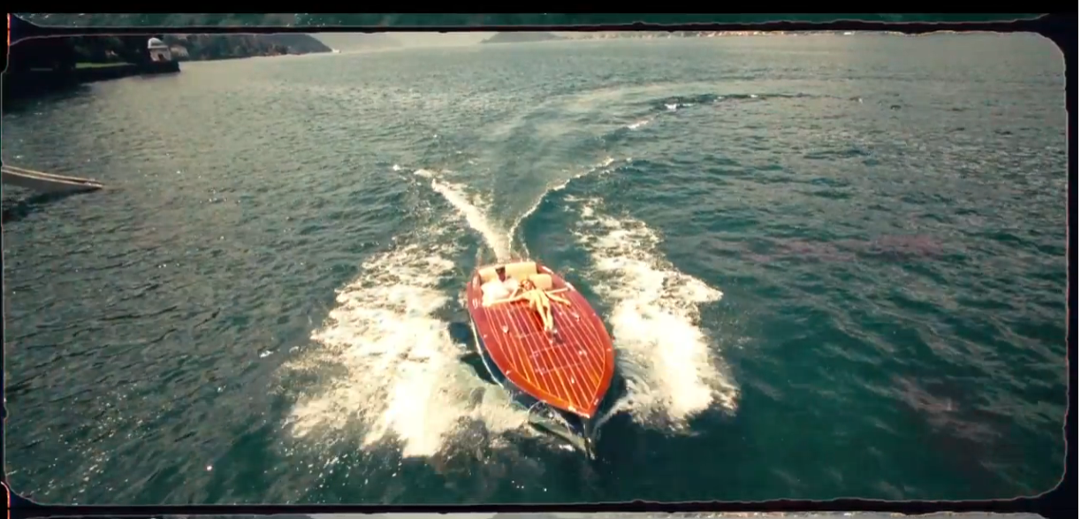
This image is taken from a commercial called ‘Spring Summer’; the image is of a beautiful girl lying on the front teak bow of a classic Italian Riva boat. The Riva speedboat is being driven across lake Como, the northern part of Italy. The mis-en-scene connotes a lifestyle of Italian beauty. The Riva boat is recognized as one of the greatest icons of Italian style, lake Como is a destination for the rich and famous. The model that lays on the bow of the boat is of such beauty that elicits desire in each and every consumer. Girls want to be her; boys want to be with her. This image connotes all the ideas above and applied to Peroni Nastro Azzurro – Italian style in a bottle.

4) The text carries two main points. The first point is around gioia di vivere (joy of life) this connotes the idea of a cool and care - free life enjoyed by every stylish Italian. Italian style has been transported around the world since the 1960’s, the same timeless fashion can be seen in every decade without seeming out of place. The second point talks about Italian heritage and the importance given to shooting every campaign in Italy. This gives the brand authenticity and kudos. Only Peroni can create such ads, they are unique, they are world class and they are like no other.

5) The importance of this page to engage and prolong the audience’s interest is the fact that the campaigns of the adverts are highly engaging and entertaining, the film quality and the story telling are what keeps the audiences attention. The casting, art direction, music and locations are so wonderful that people cannot help but want to keep watching. These ads also connote the intrinsic quality of the product. The beer is crisp and intensely refreshing, it does not have a bitter aftertaste; rather Peroni has a light fresh quality whilst having a 5.1 ABV. All of the ads are equally as fresh, crisp and powerful.
Because each campaign is different, this prolongs the audience’s interest. The first ad is the story of the blue ribbon (Nastro Azzurro). The blue ribbon I represented by blue paint that travels and hits a series of recognized Italian iconic images, from the grill of an Alpha Romeo to the shade of an arc lamp. The paint then runs down the sound of a beautiful models face connoting that Peroni belongs in the high glamour world of fashion. The paint itself becomes and blue ribbon that then wraps itself onto the bottles label and becomes the labels longstanding design.

Overall analysis:

1) The overall message being communicated about the product, Peroni Nastro Azzuro is that by drinking it the consumer is some how a part of the world image and lifestyle being represented in this site. The idea is by drinking Peroni Nastro Azzurro the consumer is suddenly that much more stylish, that much more sophisticated and even a little bit more Italian. The image of this beer is clearly differentiated from any other beer, connoting that Peroni is not for the mainstream but for a more sophisticated urbanite that appreciates style and fashion. This therefore substaniciates the premium price attached to Peroni Nastro Azzurro. In the bars of London it can cost over £5 a pint. The first beer to ever reach this level. Considering it costs no more to produce the ingredients and it is the same brewing process than any other beer, the increased profit to the company is delivered through the premium advertising, the premium brand image which is encased within this website.

2) The website attracts and engages a modern audience through having a very modern looking design to its pages. The fonts used are modern, the use of white space and a sophisticated scrolling bar helps the audience navigate easier and simpler. All the imagery and story telling has a high fashion cue to it, connoting all that is contemporary in the world of style. The images also feature young, cool, sophisticated urbanites with the idea of attracting the mirror imaging of these people in its consumer base.

3) The advertising featured on the website challenges conventional methods of beer marketing. Beer marketing is conventionally targeted towards the male gender. Conventional marketing would feature very recognizable and stereotypical social occasions where the product is consumed. Peroni took the brave steps to break these conventions by launching a beer that was unisex, it appealed equally to men as to women. The time was 2005 and the market was ready for something different. A declining marking in products such as: Lads mags and the increasing emergence of the metrosexual for example, males that were less conventionally macho and with stereotypical attitudes. Society was ready for a product that didn’t rely on these images and attitudes that was fresher, cooler, modern and more relevant then any other beer on the market. New/social media is an important part of this website with Facebook, Twitter and YouTube links that allow the website to expand its conversation beyond the conventional online channel (I.E the website) into the social psyche of the consumer.

4) The website has been successful targeting the specific audience because it has many thousands of hits, the Facebook page has many followers and likes and twitter is alive with consumer conversation. Whilst the website is only apart of Peroni Nastro Azzurro’s marketing mix. The fact that Peroni Nastro Azzurro is the fastest selling premium beer today connotes that every part of the consumer journey that is touched by the different marketing channels has been successful.

5) The ideology of Peroni Nastro Azzurro is based on the fact that Italy connotes one powerful concept that is stronger then any other country to copy and that is ‘Style’. Italian style has been exported across to every country since the 1960’s, whether that is sophisticated black suits or the stiletto heel. Therefore Peroni Nastro Azzurro being an Italian brand has sort to leverage this truth. Its strategic platform is “when it comes to style no one does it better then the Italians” and therefore Peroni represents “Italian style in a bottle”. The strategic platform informs the creative platform which acts as a launchpad for all new creative campaigns, creative activations or communications. This platform is bought alive by six words: Prada Italy, Armani Italy, Peroni Italy. Peroni Italy is designed as if you could find it on the inside of a sophisticated, expensive Italian made suit. This Signature lockup connotes and embodies the values, beliefs and ideologies of the brand in one simple marque. Everything that Peroni does represents a premium lifestyle creating an aspirational world that attracts consumers that want to be a part of that premium lifestyle therefore the consumer is prepared to pay a premium price for a premium product to be a part of that premium life.
Paris Cowley.

