Website analysis.
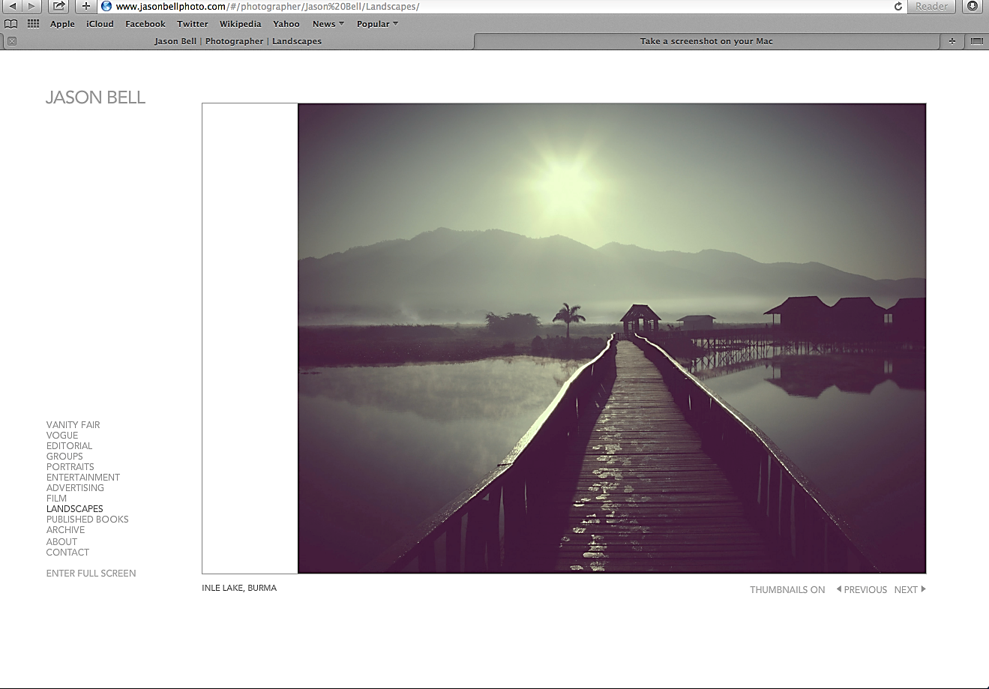

The website above is for a photography company owned by Jason Bell. It is targeted for adults 24-40. This is represented by the simplistic design and calm colours, like the pale purples and greens. Not only do his pictures follow this theme but also his website fonts and background by the light grey colour for his font and the plain white background. The website at first glance looks like it would be targeted at women because stereotypically women are seen as being more into photography than men and also the design could represent purity with the white background. This could also appear quite angelic because angels are always represented in white clothing. However it could also be targeted at men as there are no aspects of the website that connotes it is only for women, for example, there are no colours on the website which would attract one gender more than the other. Jason Bell has used the unisex colours and the simple design to entice people of different genders, personalities and interests to his work, this makes his website more about the art. Additionally I think the website attracts middle to upper class people because the images are of excellent quality and are taken in places that not many people are fortunate enough to visit. Also the website its self would connote these social classes because Jason creates extremely high end and professional work which would therefore target a high end audience. Its calm and pure vibe which stereotypically the upper classes are interested in, this is why they are often represented in the media as being into classical music which is seen as quite a high end genre of music. There are plenty of options on the website to choose from which means that his website is great for a variety of different people. There are categories from the royal family, celebrities, landscapes, film posters and many more amazing projects that he has taken part in. Some of these options connote Jason’s high end work because he has done projects with the royal family and celebrities.

When the audience first sees the front page the first thing their eyes are drawn to is the big picture on the right. The first picture shown on the front page is of a pier on a tranquil lake. The colours are very pure, gentle and more mature for the audience targeted. Also this targets a higher class of people because they may be able to visit these places and appreciate the genre of work better than somebody who had never experienced anything in the image. Additionally the fonts are very simple and are just in the colour black. Jason Bell hasn’t tried to shout out at people with bright colours or big fonts, this is because he wants his audience’s attention to be just on his work and nothing else. The website is very simple, easy to use and easy to navigate. This also attracts the targeted audience immediately because the website is following the design of simplicity and minimalizing the amount of fuss needed by the audience to find what they are looking for. This also means with simplicity that the audience are all eyes on his work. All the audience has to do is pick a category in which they want to explore and then just scroll through the pictures in that category. All of this on the front page immediately grabs the chosen audience’s attention because it is immediately presenting them with his work and giving them the opportunity to explore more of this work. Some of the audience may not recognise where the image on the front is taken however there are many options for them to explore. Overall his website has several features that connote high art.

The industry that Jason Bell works with is immediately identified when the audience clicks on his website because the first thing that is seen is a big photograph which has been taken professionally with lots of care and precision. It is very clear that the picture has been taken by a professional and not just any random person due to the way it has been taken and the timing needed to get the perfect sunset and tranquil water. It is also very clear by the polished finish of the website and the simplistic design. Stereotypically photographers have very pure and calm views on things, they believe that it’s not about screaming out to your audience or trying to impress them with big bold statements. Photographers also value nature and its beauty, this is why nature is conventionally photographed. It is about taking something simple like a sunset and timing the photograph to catch the perfect view or presentation of it. Jason has represented this belief by using a very plain background of just pure white and a very simple font in black to make his images stand out more to the audience and using them to impress and attract his target audiences. It is obvious to see from Jason Bell’s website that he prefers the simple way of taking photographs instead of doing anything fancy or over the top.

The websites layout allows the audience to navigate easily by not including lots of confusing information about the artist and his work and simply presenting his photographs for his audience to enjoy, this makes the focus of the audience’s attention solely on Jason Bell’s work. Additionally his website has options for the audience to pick from so they don’t have to go through loads of pictures just to find what they want. There are options from landscapes, to portraits, entertainment and more, which connotes that he photographs many different images and can target a wide variety pf people through this. Additionally if the audience does want to find out more about the artist and his work then there is an option ‘about me’ in which people can find out more. This includes information about past projects he has been involved in and certain aspects of his personal life. There is also an option for ‘contact me’ if his audience wants him to photograph a special moment of theirs or just want to complement his work. The specific audience is targeted because of the slick and tidy feel of the website and the navigating, which gives the overall website a very high class feel. It isn’t messy or unorganised which would give the feel of a lower class audience.

An aspect of the website that may draw in the audience is the main picture on the right hand side of the screen. The image connotes purity, this is because of its tranquil and natural feel. Additionally the white background makes the picture stand out even more because it is the only bit of colour on the screen. Jason Bell has used these connotations to link back to his ideologies. Also the content of the images are generally of places that only the upper class would ever be able to witness first hand. These places are normally the most naturally beautiful places found. That is what attracts the audience to them. If it’s not the beautiful landscapes then it is the pictures of famous celebrities or the Royal family that attracts the audience. Jason Bell is a very famous photographer and therefore he gets great opportunities to photograph people like the royal family and famous celebrities like Angelina Jolie and Ed Sheeran. So therefore the audience can be attracted to their favourite celebrity or Royal family member. Therefore this gain represents and targets the upper classes because the royal family and celebrities are all seen as being upper class.

There is hardly any use of new media on Jason Bells website, this could represent him as quite traditional in his work. This also connotes that Jason values using his work to speak for him and believes that real professionals are recommended and work to build up a fan base instead of advertising an abundance on social media sites.. This also anchors his target audience because the upper class are genuinely more academic and don’t traditionally use social media as much as lower classes may use. However he does include his twitter name on his contact me section. This could be because twitter is a great way of sharing Jason’s work and talking to people who may want to know more about him. Twitter also has many of the facilities of other social media sites all in one so it is much easier than having lots of different media sites to share his work. These include; sharing images, writing statuses, private messaging people and following people important

The text on the homepage targets the audience because it is very basic, it isn’t dramatic and therefore it doesn’t distract people from Jason’s work which is what they have come to look at. The target audience is upper class 24-40 year olds, so by having the writing very little, the font of normal sizing, the colour just plain black and also the fact that there isn’t much writing is very conventional of this audience. This is conventional of this audience because it gives the website a very professional and high end representation. Similarly to a point made previous, the website also has a very academic and intelligent feel to it with is slick business like feel. The font that has been used is also very smart and professional and therefore this represents Jason as being very experienced and adept in his work, which attracts the audience to his business.

The images of people on Jason’s website represents that he gets paid by people to take gorgeous pictures, which is conventional of his job. There is also a meaning to why he has taken the photographs. They are not photographs of random things, most of them will have a meaning behind them. For example the main photograph on his front page connotes purity and the natural beauty amongst nature, this is represented by the tranquillity of the water. There are no big waves or anything that would connote busyness. Additionally the colours are very conventional of a photographer because they are very pure and plain which gives a professional and high end look instead of being bright and powerful. It anchors the natural theme in his pictures with the natural colours. Similarly the fonts and text are very conventional because it is quick and simple and doesn’t include lots of un-needed information that people don’t really need to know. This could connote that Jason didn’t want people to read a long description of the picture because different people interpret things differently and therefore he wanted them to interpret the picture in their own way instead of listening to what he thought about it. Also when a photographer is working they need silence and a lot of focus to get the perfect picture. The calm, silent atmosphere is then represented on Jason’s website which is conventional of an upper class photographer like Jason.

There are no moving images on this page because it is showing his work which is photographs. However his website could maybe use a moving image to give us an insight into him doing his job, showing us, the audience, around his office or maybe advertisement for his business. Additionally he could do a moving image of all of his work put together. Jason hasn’t used any moving images because traditionally moving image would be used to advertise or publicise his work, this isn’t what Jason wanted to do, he wants to build up his fan base by just using his photographs and nothing else.

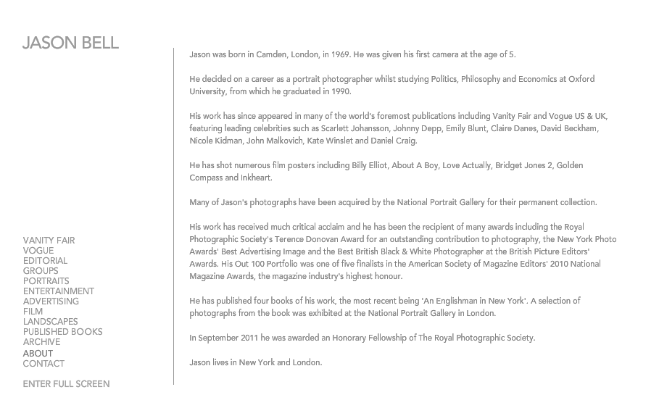

This is Jason Bells “about” page. This has been included in the website for people who want to find out more about him and his work. It is a useful page if somebody is thinking about using his service, it gives them more information about other bits of work he has done and other projects he has been involved in. It also just gives a little more information not just about his work but about him as a person. An example of information the audience may want to know is, “his work has received much critical acclaim and he has been the recipient of many awards including the royal photography society’s Terence Donovan award for outstanding contribution to photography, the new York photo awards best advertising image and the best British black & white photographer at the British picture editors’ awards”. This information is useful to the audience because it gives an insight to his career and how successful he has been throughout his career. This also connotes high class work because Jason is receiving awards from the Queen and she is the highest class member of the country. Sometimes you can’t find out much about someone just through the pictures they take. You can get an insight into their interests and their personality however you can’t really find out facts about them, for example, “he has shot numerous films”. Not many people would know this fact without looking at this page. This just adds a little bit more to his website and can allow the audience to feel like they know Jason and his work well. Additionally if the audience feel like they are connected with Jason they may also feel connected with his work and the reasons he captures the moments that he does. This is achieved in the text by the use of short facts like where he lives and were he was born. This allows the audience to connect with him on a personal level.

Similarly to why the page is included in the website this page also prolongs the audience’s attention to Jason and his work. This page does this by giving the audience an insight into Jason’s life, how he became a photographer and the amazing things he has accomplished in his life so far for example, his awards and honorary given to him for his photography. It engages the audience because there isn’t an abundance of writing for them to read and instead there are just little facts about him. Examples of this is the date of birth, year of graduation, projects he has been involved in and more. This page is at the bottom of the website, it is second to last before contact. This means that the audience can have a look through his website and then decide if they like his work and whether or not they want to find out more about him. By having the pages in this order is also means that the audience wont judge his work on him or his life, instead they can enjoy his work for what it is and then find out more about him if they wish to. His beliefs about photography are that the image should be able to be interpreted in many different ways depending on the reader and writing and information should adjust of change this view. This is why this page is separated. He also values the use of allowing the image to speak for itself in terms of the mood, feelings, meaning and more.

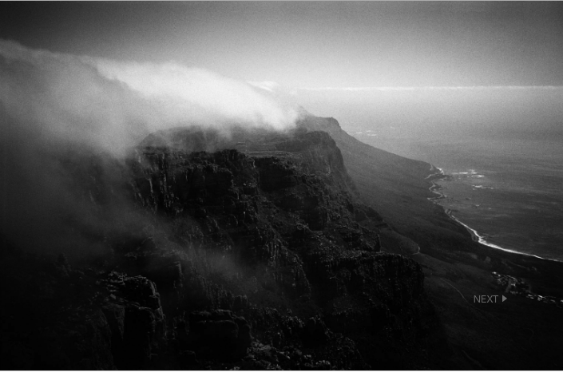
This is one of the images on Jason Bells website. This attracts the target audience because it is following the theme of tranquil and unvisited places. It also links with the theme of naturalistic colours, they are all very calm however also give a slight eeriness to the image which is only seen in very few of his images. This image could attract the target audience also because it is of a mountain or cliff somewhere that maybe the audience have visited or wish to visit. Nothing is shouting out in this image and again it is solely about the photograph and the scenery.

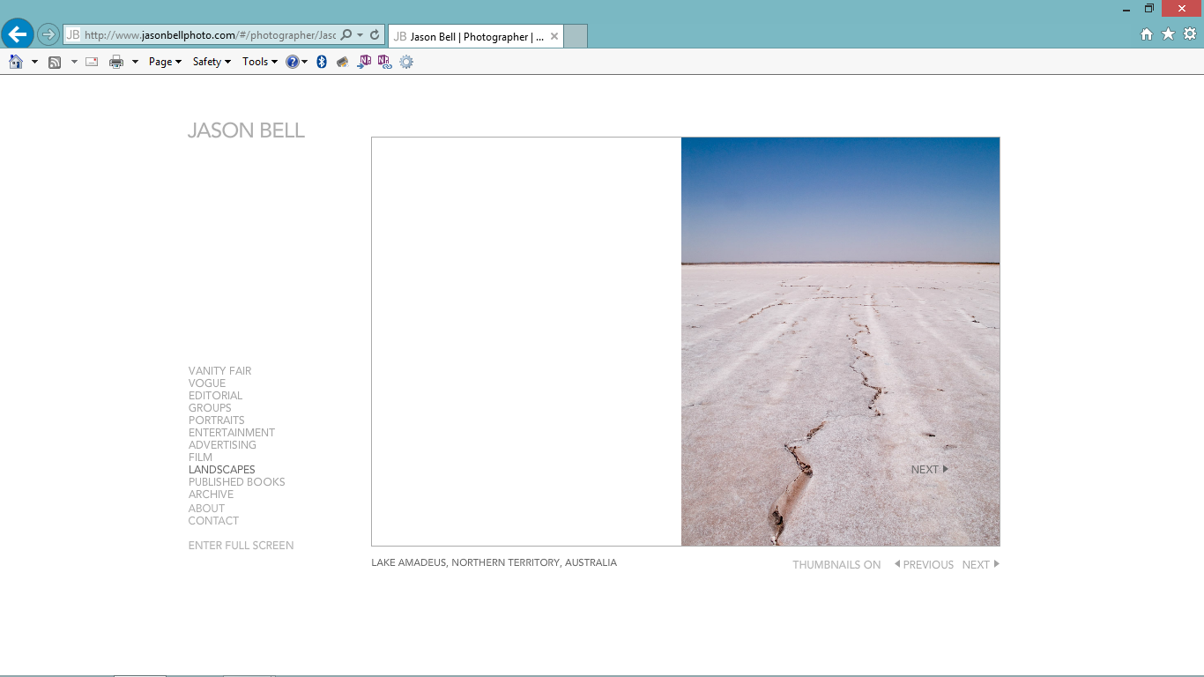
This is also a picture from his website. It is sticking with the whole theme of his work again with the natural colours and the quiet deserted theme. This piece in particular targets his audience because of the very light pale colours. It is not too bright and in the audiences face. It sticks to the calming theme of his work. The cracks in the ground could additionally add to the naturalistic theme. The image itself is very simple and doesn’t have much going on however this is the type of work that Jason does and it attracts his audience because of the fact there isn’t much going on and it is just an image of nature at its best. There isn’t anything in the photo that stands out that the audience would enjoy, it is simply a photo of nature and a place that the audience may be inspired to visit in the past or maybe the audience have already visited here or somewhere like it.

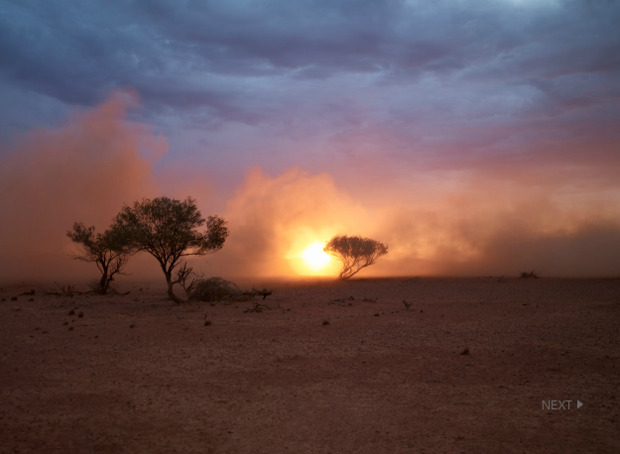
Lastly this is another one of Jason Bells images, it shows a sunset on a vacant desert. This will attract the target audience who enjoy nature and its natural beauty. This photo hasn’t been edited at all, it just took precision and timing to get this shot. It sticks with all of Jason’s themes and the colours have stayed very natural and relaxing. Jason believes that in photography it isn’t about a fancy theme or idea but about taking something natural and plain. He believes that when the photographers times the shot perfectly that they will get the perfect image. Additionally the use of careful precision and patience helps to shot the perfect picture. Additionally Jason values the use of nature’s natural resources and is patient when he is waiting for the perfect shot. He values that natural beauty takes time and care.

Most of the writing on the page will attract the audience. However the main text is the text about the work he has done and the people he has worked with. This attracts the audience the most because it is telling them more about his work which is why they are on his website. The audience are not on his website to find out about his personal life, the audience are there because of the interest they take in his work. The amount of writing attracts the audience as well because it is short and quick, it isn’t massive long paragraphs. If the audience went onto the page and found huge paragraphs it wouldn’t interest them as much as the short, sweet facts would. This is because they are really quick to read and don’t smother the audience in too much information.

The overall message and image of the company is that Jason focuses on the simplistic things and uses nature in most of his images. He doesn’t believe in big stand out pictures to get his audiences attention. He also always keeps the colours he uses very naturalistic and calming. The message he is trying to connote in his work is that the natural things in life are beautiful, and that it doesn’t need editing or adjusting. Additionally Jason is suggesting to his audience that nature is beautiful and that our society shouldn’t destroy it. The portraits he took of people also followed the simplistic design and follow with the theme of being natural, for example; the makeup is very light and the background very plain. This is showing the models natural beauty. Even the images he takes of people still stick to his overall message for his product and keep the natural colours and the plain backgrounds. This consequently leads to the audience’s attention on the main image in the picture, this could be nature or a person. Also in all of his portraits none of the women or men are wearing lots of makeup, the makeup being worn is very natural and again follows Jason’s overall ideologies.

The website attracts the modern audience by its slick and professional look. It is simple and easy to use which makes it easy for any age to use and for people with very little knowledge on using technology. It also has a very modern look and feel by the colours that have been used, the colours may be very natural or plain however it means that it can attract everyone to the website and also gives it a very professional feel. With the help of the colours the whole website has a very modern representation. Instead of the colours being very bright and maybe slightly childish, they are very neutral and quite mature. The images also fits in with the modern audience because Jason has pictures from events and celebrities that have happened recently like the Royal Wedding. For example the modern audience is very interested in celebrities and their lifestyles and therefore the audience will enjoy the photographs that have been taken of famous celebrities. Additionally the older modern generation can enjoy the pictures of the royal family and the beautiful pictures of nature if that is of their interest.

The website has stuck to very conventional ways of advertisement, it hasn’t used very much new media to advertise the product. The reason it has stayed very conventional with the advertisement is because Jason throughout his whole website has stayed very classic and natural and therefore he has carried this through by not using any form of advertisement on his website. The only form of new media that Jason has advertised is twitter which was where he started off his work. He has only used one because it is much easier to keep up with and it is the best social media sight for interacting with people and sharing his images and his business. Twitter can also show recent updates which is useful for the audience and also convenient because the audiences only sees recent and important information. This can engage the younger audience however he has also covered the older audience because he has kept the website and worked on it a lot so it is slick and easy to work. However he hasn’t advertised his business on all the social media sites. Twitter is also one of the most used social media sites and is used by a variety of younger and older audiences.

The ideologies of this institution is that photographers are very at one with nature and natural beauty. They believe that anything can be beautiful with the right precision and timing, this is connoted by the use of nature and no editing or filters. Also photographers use silence a lot in their work, they don’t work around noise and therefore a lot of their work will represent tranquil environments and surroundings. Additionally this is why Jason Bell’s website is very pure and doesn’t have much colour or text taking over his page as it would create an almost embellished or flamboyant feel to the website. This isn’t what Jason is looking for, he wants to create a calm and quiet place where people can simply enjoy his work for it is or what it is featuring. He continues this theme with his portraits, he doesn’t do anything extreme and instead proves to his audience that he doesn’t need a great background or lots of colour for something to look beautiful. This is a very inspirational way of taking photographs as the people featured are all natural and are beautiful just like that. Just the way they are. Similarly for nature, Jason is sending the same message.

Website 2:

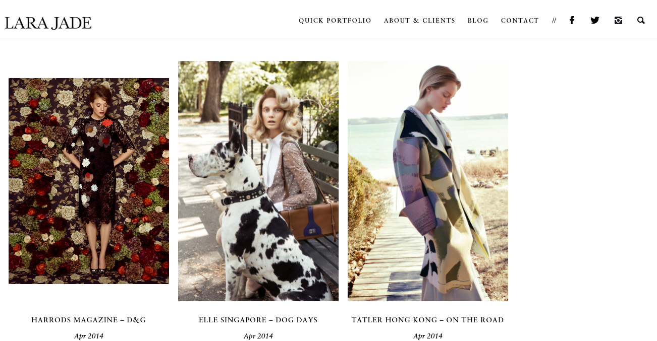
The website above is also for a photography company. Immediately from looking at the first images on the page they connote that the target audience is women. This is because women are featured in all the pictures and also the colours of the pictures are very feminine, for example the pinks, purples and oranges. The elements of the website which draw the audience in immediately are the photographs. The pieces are very retro and all have a slight 1960s type vibe to them. This representation is also carried through by their hair and makeup. The women’s makeup is very natural however their hair is very big and volumised. The use of nature on Lara photos also draw in the audience. This has worked because on the first picture she has used bright floral patterns as her background. Similarly the middle photo has been taken in a park and features a massive dog sitting next to the lady. Finally the picture to the right is taken on a beach with the summer breeze. This connotes that fashion is very much changed by the seasons and by nature. Additionally the font is very elegant because it isn’t in a dark bold colour and isn’t really the type of font that a man would stereotypically use. Additionally it is in a small size so it doesn’t take up too much room and is in a clear and easy to read font. Stereotypically girls who are interested in fashion and clothes are very girly. The use of the black colour text also gives the website quite a mature and professional feel because it isn’t in bright childish colours. The font used is in capital letters, this is so that is stands to the audience however it isn’t too bold that it takes their attention away from the images on the screen. The website is aimed for women of middle to upper class, this is because all the women in the pictures have very upright postures and are dressed very formally and of good class. None of the women are slouched or dressed in rags, instead they are all sitting very formally and with a good posture.

Also the colours in the pictures are very mature and grown up because they are quite dark and natural instead of being bright pop colours. The age group is probably of women aged 24-35. This is because the colours and clothing connote maturity however they are not of elderly fashion, the clothing is still very young and fashionable. The website could attract many psychographics, this is due to the variety in the pictures for example; the different backgrounds, scenery, clothing and patterns. There is a variation between the calm beach picture to the fairly busy floral print dress and background. However I would say that the website from first glance is targeting women who are into fashion, this is because in all of the photographs the women are modelling some great fashion pieces for example the cow patch patterned coat in pale colours like purple and yellow. In the top right hand corner of the page it can be seen that she has put links to all of her social media accounts, including; Facebook, Instagram and her twitter. This has been done because new media is taking over normal websites and also it is very conventional of a photographer to post their work on the social media sites for their audience to view. Lara has done this to expand her fan base. This is because the more sites and social media she can be part of, the more people will see her work and contact her. This additionally is targeting lots of different age groups because some younger people may use twitter and Instagram and all the new media whereas the older people will find her website through the internet. This makes it much easier for her to build a fan and client base.

The front page immediately grabs this particular audience’s attention because the first thing the audience can see is the three main photographs in the centre of the page. These photos feature the fashion statements discussed above and therefore would catch the audience’s eye straight away for example the coat is the main fashion piece in the photo and the rest of the outfit is very plain so that the audience focuses on the coat. The use of nature in the background is very conventional of the industry because photographers use the natural outdoors to express natural beauty not only in nature but also in people. Additionally the white background connotes purity because it is a very clean and basic colour and women are seen as being very pure and innocent. Also it emphasises the colour on the photographs and makes them stand out. This also works the same for the black writing on the page. Additionally the background and the font of the website is very plain and doesn’t have much going on. It is connoting that photographers have a way of making plain or natural things look beautiful. For instance Lara’s website is very plain however she has still managed to catch people’s attention and made it look beautiful. This is conventional because artists don’t usually use text to describe their images instead they leave them blank and allow the audience themselves to interpret the picture how they wish. Also there is nothing on the page that would take the audiences eyes off of the pictures as they are the main feature on the page. This focuses the audience on the pictures causing their attention to be drawn to the colours and backgrounds in the photos and the outfits included in them all. Also the website is very easy to use as it has little option boxes up in the top right hand corner of the page so that it is quick and simplistic. For example the options have drop down boxes with broken down options to choose from. The pictures may have some very vibrant colours however they are all quite calm, there is nothing extreme happening in any of them. For instance; the photo on the far right hand side is of a women at a beach, she is wearing a very colourful jacket however she is represented very calm and relaxed. This could also be called juxtaposition, which means that her jacket is very vibrant however this is controversial because she is being very calm and relaxed which clashes with the bright and busy jacket. This is very attention grabbing because it isn’t something that the audience would see very often in a photo. This grabs the specific audience’s attention because the fashion and the body language and background contradict each other. This is a different way of taking photographs and would interest the audience.

The genre of the industry is established immediately due to the bright colours and the mis en scene of the photos. The genre is outdoors fashion. For example, in all of the photographs nature has been included somewhere for example the floral print background in the first image. This is so that the audience can clearly see the link between photographers and nature which is in their ideology. Additionally in all of the photos the women are wearing big fashion pieces. The audience can immediately recognise the genre because the three pictures stand out on the page. Also all of the women in the photo are posing as if they are modelling the clothing against the background. Their makeup is all quite natural which interlinks with the theme of the nature as well. Similarly the dates underneath the images show it was the same month of the same year that these were taken. This connotes that the audience can style and pull off lots of different fashions in the same time of year. This again interlinks with the genre that Lara works with and is trying to put across to her audience. This means that Lara is a seasonal photographer and photographs seasonal items for that time of year.

Lara has used a blog as a type of marketing strategy for her business. She has used a blog because it is an easy way for fashion lovers to search for great fashion bloggers and then find Lara. Also stereotypically there are many fashion lovers that write or read blogs and therefore this would be a great way for Lara to get her product out there and to the right people. Also this would allow Lara to give her audience an insight into why she photographs the things she does and where her inspiration for this type of photography came from for example she may have been brought up around fashion and this may have led to her career in photographing these images. Additionally she has also got a link to her Instagram. Instagram is a great place for photographers because they can share their photos with all of their followers and also be contacted by followers who are interested in her work too. These two social media sites would bring in a lot of her target audience because they are ways of finding people that photograph things they are into and therefore the audience would come across Lara’s work and finds her webpage through that. The psychographics of the target audience would be women who have interests in nature and fashion. The audience also have an interest in photography or original ways of laying out and photographing these images.

The websites layout allows the audience to navigate easily due to the fact that Lara has given her audience options of what to look at. The options she has given are; blog, quick portfolio, about& clients and contact. This makes it easy for her audience to find what they want to look at and click on it. Additionally there is no random information like her favourite foods or unwanted information that the audience may not want to see or read. Instead there is information about her career and her childhood, also it tells the audience where she found her inspiration for photography. The audience have been given the option to find out more about Lara, her childhood and why she came to become a photographer, instead of it being given to them without a choice. The options are very clear at the top right hand corner of the page, so the audience can immediately find it and choose what it is that they want to explore. This is useful for a female audience because typically females are represented as being very organised and tidy and therefore if there was no organisation on the website then it may put off her female audience from viewing her work. There is nothing else on the page except some examples of Lara’s work and the options. This means that all of the attention is either on the photos or on what can be explored next. Also if the audience hovers over the pictures it gives them the chance to explore that particular collection of photos, which makes it even easier for the audience to explore her work. This is because it means that the audience don’t need to look through every photograph of hers just to find the particular photo they were looking for.

There are no moving images on Lara’s page. This is due to the fact that in photography it is hard to fit moving images into your website because all of the work they do is in photographs. However Lara could have maybe put together a montage of her photos or maybe a short clip of how she takes her pictures, this would give the audience an insight into her work.

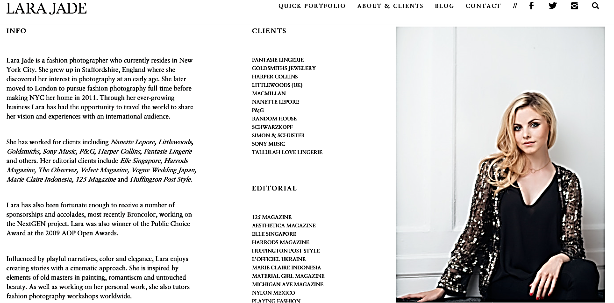

This is another page from Lara Jade’s photography website, this page has been included so that her audience could find out more about her. The page includes a picture of her so the audience can feel connected with her and also lots of information about her and her work. This is important to the target audience because the more connected to the photographer they feel the more connected they will be with her work. This is great for both Lara and her audience because it means that Lara is building a relationship with her audience via the internet and also it means that the audience can understand her inspirations and ideology’s on photography. Along the same lines as the information on her work, there is also a list of her clients and projects she has been involved in. this list includes clients from Littlewoods to Sony music. This represents her as being a high class and well known photographer. Not only has Lara included the list of clients and information about her for her audience but she has also included it for other businesses who may want to use her service for events or advertisement. This gives other businesses a good impression of Lara and therefore will make them want to use her service even more for example the projects she has been involved in like the Littlewoods adverts and Sony music. By having such big brands as her clients it also connotes that she is great at her job and great at working with people and delivering them what they asked for. Similarly to Jason Bell’s website, Lara has put her ‘about & clients’ section after her photographs. This gives the audience the chance to look at her work first and then give them the option to find out more about her. It also means that this page won’t twist the audience’s views on her work.

This not only engages but it also prolongs the audience’s attention. This is because instead of just giving them the photos and that’s it, she has given them the chance to connect with her and her work. The audience can do this by reading about Lara’s history and finding out how she came to be so passionate about her work and her photographs. It can also give the audience a chance to find out what the messages are behind her images and if there was any specific reasons behind her choice of outfits or scenery in the photographs, for example the use of the beach as the background for the image on the right could link with the clothing she is wearing or the message she was trying to represent. By having this page after the photographs it means that the audience can interpret the pictures in their own way and find their own meaning behind them. Then the audience can take a look at Lara’s interpretations on her images and the audience will be able to see the images in a different way. This is also teaching the audience that there are many different ways of interpreting an image, there is never just one meaning behind an image, for example an image could connote happiness and sadness depending on how the audience interpret it. This can be quite interesting for the audience because it is showing them the different ways of reading an image and the different messages an image can connote.
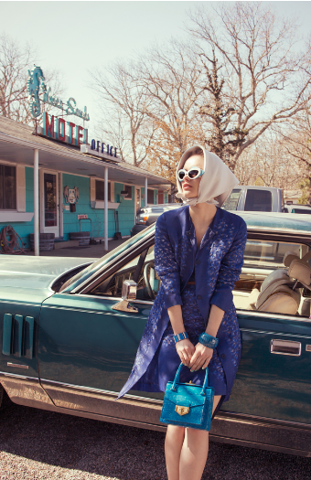
This is one of the images on Lara’s website. It specifically targets the audience by the bold fashion statements in the picture and the nature featured in the background. The retro vibe is still clear by the big white sunglasses and the old fashioned American diner. Additionally the female model is leaning against an old retro American car. The whole vibe of this image is very 60’s and fits in with Lara’s style. The image targets the specific audience because the retro clothing is in fashion at the moment and so the young audience of about 25 would be very interested in this theme because it is in fashion and also because they wouldn’t of been around in this decade. Also the image targets women due to the clothing and also because the main character in the image is a woman. The class of the character in the image is quite high class because she is leaning up against a very expensive car of this decade. This connotes that Lara’s work is of high class and quality too. The psychographics of the audience would be fashion and they may also have interests in the 60’s and the fashion and attitudes of people in this decade or era.

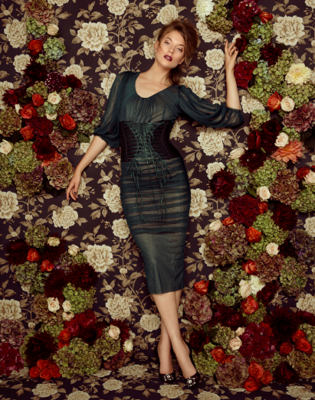
This is also an image from Lara’s website. The background of this image is very bright and floral which anchors her theme of nature and natural beauty. The lady model is wearing quite natural makeup with bright lipstick, this sticks to the theme of natural beauty similarly. Additionally the outfit and hair style she is modelling is very retro and 1960’s style. This is easy to tell because her hair is in a classic up do with a very volumised fringe. The image is very feminine due to the elegant pose that the model is holding and also the colours are very mature and feminine. For instance the reds and creams.

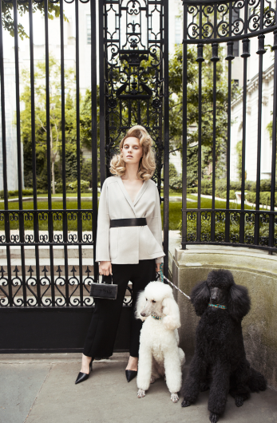
Finally this is another image from Lara’s website. This picture features a lady and her two dogs. She is standing outside what looks like a big house with steel gates. Similarly to the other images, the lady is sporting the big 60’s up do and very classic and mature clothing. Like the other images that Lara has taken, this image also includes nature in it. The greenery in the background make for lovely scenery and give the photograph a very natural feel.
Lara values the use of nature in all of her photographs, this is connoted by the use of greenery in the background and also the use of the poodles next to the model. Lara also has a strong belief that images should be quite simple so that the audience’s attention is on the outfits, this also allows the audience to interpret the outfit however they wish.

The text on the page that targets the audience are mainly the little paragraphs about Lara’s background and influences, for example the short line about where she was brought up and the country she is currently living in. These stand out due to them being very short and sweet and not having masses of writing to get through. As the audience, we don’t want to see massive paragraphs as it will put the reader off reading them. whereas if they are short and sweet facts about Lara and her work then the audience are much more likely to want to read them because they are quick to read and only contain the information that the audience may find useful. The reason the audience’s attention is drawn straight to the facts is because it takes up most of the page and therefore it is the first thing the audience see when they click on the page. It is obvious when the audience read the little facts that it is targeted for them. This is due to the depth of information about Lara.

The overall message of Lara’s company is that women and places are naturally beautiful. Lara’s message is that women are naturally beautiful and therefore by placing them in a mis-en-scene that is natural it is emphasising her message and the natural beauty of the women. None of her models had any extreme makeup or editing done to them and this gives out a very positive message out to her audience. Additionally Lara has taken a big interest to the 1960’s theme because their fashion and way of doing hair and makeup was a lot different to modern times and therefore this interests her. The 1960’s theme is present in all of her photographs and her scenery. Similarly to other photography websites, Lara has tried to keep the website itself very plain and simple so that all of her photos stand out. Also this is connoting to her audience that they don’t need big bold colourful statements to get people’s attention this is because the specific audience have come to her website to see her photographs and to look at how she represents certain fashion ideas, therefore they don’t need big bold statements because that isn’t the reason that the audience have come to the website. Natural mis-en-scenes and women can be made to look beautiful it is just the way they are presented. For instance the purity of her background worked well against the busyness of her photos. This consequently lead to a very natural feel on her website, this was what Lara wanted to represent her work as. She didn’t want her audience to think that too much work went into it, instead it almost has an effortless beauty to it. This also links to her message about the natural and effortless beauty that women and nature possess.

The website attracts the modern audience by the social media sites that are featured in the top right hand corner, this represents that Lara is very up to date with all the new websites and social media sites and it also connotes that she has a very wide variety of people coming in from lots of different media sites, this connotes a wide fan base. Also Lara has got a very slick and professional website which looks very mature and business like. This looks a lot better compared to other websites which might appear a bit childish with bright colours. It is also very organised and everything is put into category’s which makes it extremely easy for the audience to guide their way around the website. All of this together connotes a slick and polished representation of the website. Finally modern fashion can quite often get inspiration from 60’s fashion. Therefore the photographs can interest the fashion lovers who are exploring Lara’s website due to her strong interest in the 60’s fashion and her unique way of presenting it. This interests her specific audience of young women interested in old fashioned fashion.

There is much more use of new media in the industry’s advertisement. This is because new media is becoming increasingly popular amongst many different audiences. However it is still quite conventional of photographers as they tend to use apps like Instagram to advertise their photos. This is because it is easy to use and it is an app dedicated to sharing pictures with people, this is perfect for photographers because it means that they can build up a great fan base by advertising their work so that new people can see it and will be intrigued to see more. The fan base would be full of people that enjoy the same era of fashion and ways of presenting this fashion and have the same interests as Lara does. Part of this way of advertisement isn’t very conventional however, this is because conventionally advertisement would be done over the television or on posters and more. This represents that the new media is taking over the old traditional way of advertising a product or service. The fact that Lara is following trends and advertising on new media is proving to her audience that she can be very up to date and trendy with her work and it also means that she is attracting younger audiences to her work as well as the older audiences. This is great for her business because it means that Lara is building herself a fan full of a variety of audiences all interested in the same thing. This also means the bigger her fan base the more amazing opportunities are going to come up for her.

The website has been very successful in targeting the specific audience. This is due to the modern approach that Lara has taken to her webpage. It is very professional with the white and the black as her background and font. However juxtaposition has taken place with the fact that she is photographing with more retro scenery and outfits which are very colourful and more fun.

The values, attitudes and beliefs of this institution is that nature is beautiful and should be featured more in the audience’s everyday life. Additionally Lara has tried to get across her belief that women are beautiful too and that they don’t need to be covered head to toe in makeup just to look like their representation of beautiful. Similarly Lara has used juxtaposition to prove that new technology and fashions are taking over however old fashions are also popular and that sometimes the new can’t always replace the old and Lara is voicing this strong view of hers in her work. Lara has represented this in her whole website because she has used a modern approach as her background and professional fonts to grab the reader’s eyes however she has photographed retro things, for example, the American diners and old fashioned car. This connotes a lot about her personality and her attitudes for example her attitudes about women’s natural beauty and her love for retro fashion in her personality. Finally Lara wants her work to look effortless, she knows just how hard it can be to take the perfect shot however she wants her audience to feel like they are effortless photos because it connotes that women and nature have effortless beauty. That nature and natural beauty is effortless, along with the old and the new all on one effortless website. The website just looks perfectly effortless and sometimes this is a great thing and this is what Lara believes in and how Lara feels photography should be represented because it connotes that human, animals and nature are all effortlessly beautiful and that they don’t need editing or changing in any way, shape or form. This is because everything and everybody are perfectly and perfectly beautiful in their own way naturally.

