How to use Final Cut Express

- Create a folder on your desktop named ‘Final Cut’
- Using the magnifying glass on the top right hand of the Mac screen, type in ‘Final Cut’
- A box will appear asking you to choose the format of your work.
- Select the format: AVCHD APPLE INTERMEDIATE CODEC 1920 X 1080i50
- Your ‘destination folder’ should be a folder on your desktop. Click on the box marked ‘destination’ and ‘choose other folder’. Then select your ‘final cut’ folder.

Final Cut will now open.

Your desktop:
CANVAS
VIEWER
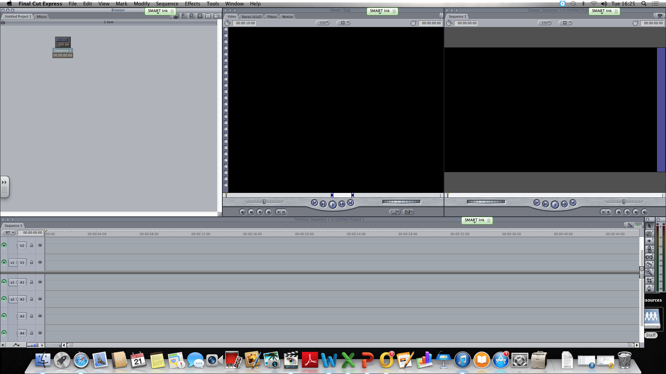
BIN---

TIMELINE

TO IMPORT FOOTAGE

- Download the clips from Edmodo and put them on your desktop
- In Final Cut, select ‘File’ . ‘Import’, ‘Files’ and select the video from your desktop.
- This will now arrive in your ‘bin’.
- Click and drag the video onto your timeline- make sure you don’t split the footage. The footage should appear as a solid grey block on the time- then release the mouse.
- On your ‘timeline’ you will have a ‘V’ track (video) and ‘A’ track (Audio). You will be able to add layers of footage onto the track later.

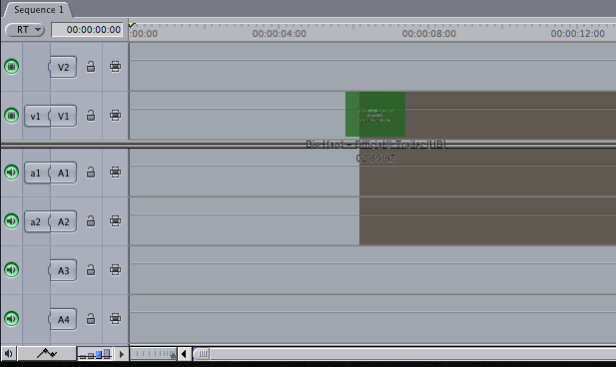

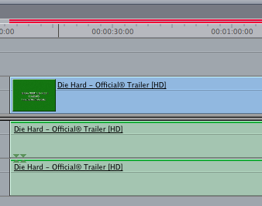
YOU MUST RENDER YOUR FOOTAGE BEFORE YOU TRY AND EDIT

When you import the footage you will see a red line in the timeline
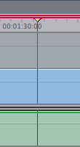
- You need to ‘render’ the footage.
- On the toolbar (top of the screen) click on ‘Sequence’, ‘Render selection’ and ‘both’.
- Make sure your yellow scroller is on the footage.
Unrendered footage
Once this is done you can begin to edit!

Yellow scroller

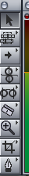
TOOLS (right hand side of the screen)
Selection tool

Cutting tool/ razor tool

These are the main tools you need. To move footage around the timeline, make sure you’ve clicked on the selection tool.

TO USE YOUR CUTTING TOOL

Find the place in the footage where you want to cut and make sure your scroller is resting on that point. Select the cutting tool and drag it over to the point where the scroller is sitting. When you place your cutting tool over the scroller you will get a thick grey line. Click the mouse and you will have cut your footage.

You can then move the footage along the timeline to clearly see where the cut is.
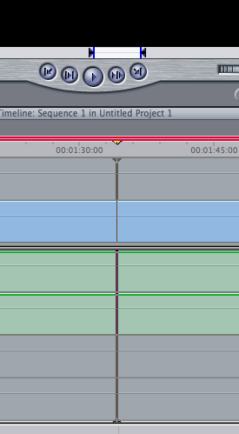
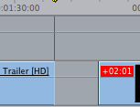

Moving footage along the timeline with the selection tool
Pulling the cutting tool to the scroller

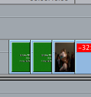
ARRANGING FOOTAGE

You can now start to arrange your footage in the order that you want.

- When you want to watch what you’ve made, move the scroller to the start of the footage and press the space bar.

- To delete footage, click on the piece that you want to delete and press back space.

- To be able to delete audio and keep the video (or vice versa) you need to ‘unlink’ the footage by clicking on this button on the timeline.

- You can now separate the audio from the video.

ADDING TRANSITIONS

- Make sure the scroller is at the ‘cut’ where you want to add a transition.
- Click on ‘effects’ and then ‘video transitions’. Choose the transition and it will appear in the timeline.
