Website Analysis
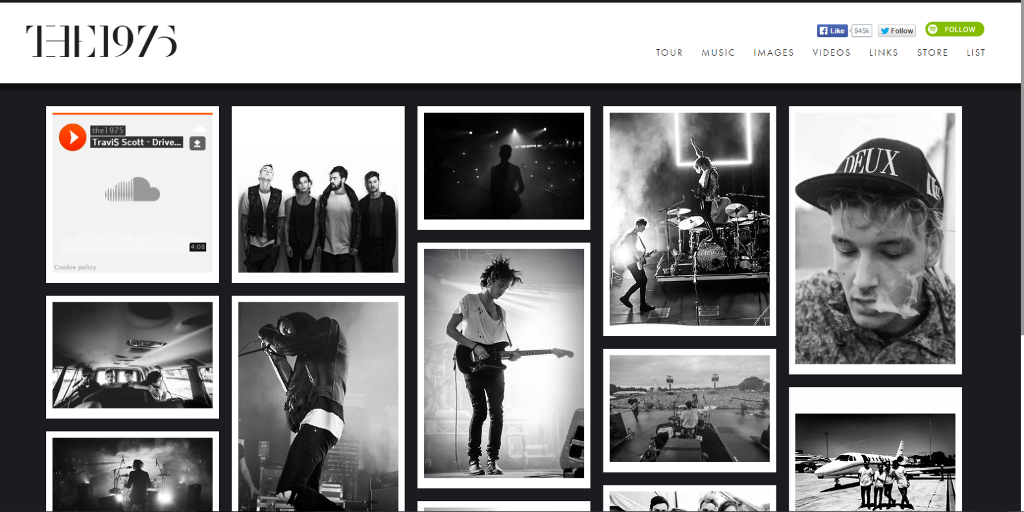
The 1975 – Homepage
- The target audience for this website would be aspiring middle/working class people of both genders aged 15-24. The website is made to attract the target audience as it incorporates links to social media and sharing websites such as Facebook, Twitter, Spotify and SoundCloud that appeal this specific audience due to their ages. People of this younger age would find the integration with social media useful and convenient as they would usually already have an account on these sites. This encourages them to follow the band on the various social media websites. The website is mainly in black and white to connote a retro feeling which is reflected in the band’s music. The homepage is a collage style collection of photos from social media sites such as Twitter and Instagram from photoshoots and photos showing the band performing. This appeals to the target audience again as it is very well integrated with social media which gives the audience the opportunity to be up to date with the bands actions and movements on tour.
- The homepage immediately grabs the attention of the viewer by containing pictures of energetic and euphoric live performance. The website offers escapism to the target audience by allowing them to be part of the band’s lives through photos from every second that they are touring and performing. The band are represented as very conventional of the “Indie” Rock genre as they insist on everything being black and white. They are also represented as being very interested in the art of the music as the layout of the homepage is a collage style collection of photos that represent the band on stage, this connotes the euphoria of their live performance. There are white frames around each of the photos on the homepage – they are made to look like Polaroid photos, this connotes the band is very retro and influenced by 70s/80s music.
- The website establishes the indie rock genre by containing pictures of live performance, picture of guitars and drum kits. The way the band is dressed (in black and white) and the colours incorporated in the website also connote the rebellious nature of the genre. The website also connotes the extravagance of the “rock n roll lifestyle” with pictures of the band boarding private jets and going on nights out, it eliminates all modesty which is a common convention of the genre.
- The website has used links to buying albums and singles on iTunes as a pop-up as soon as the website is opened this is effective as it advertises the albums, EPs and singles as soon as the website loads. It also has links to music sharing websites such as SoundCloud and Spotify to encourage people to listen to the band’s music and follow the band on these sites. The website also has a store which is advertised among the collage of photos from the band touring. This is an effective marketing strategy as the audience will see the adverts whilst browsing the images and be more prone to impulse buying of band merchandise such as clothes or EPs. These ads would be targeted at audience members of younger ages (15-24) as they are more likely to want to spend the money to wear the merchandise.
- The homepage allows the audience to navigate easily through a banner at the top of the homepage underneath the logo and well placed links to social media sites and the merchandise store. This appeals to the specific target audience as the homepage is very logical and easy to use making visiting the website a more pleasant experience. This represents the 1975 as being very involved with their fans and that they make an effort to connect with the audience by making their website easy to use and well integrated with other sites
- The audience would immediately be attracted to the slick layout and retro feel of the website. For example the images on the homepage are made to look like Polaroid photos which connotes the band’s 70s/80s influenced music. The influence from 70s/80s Sci-Fi films is also evident from the images on the homepage of their live performance. The images of euphoric live performance on a stage with many different flashing lights is comparable to a spaceship from films such as “ET” and “Close Encounters of the Third Kind.” These images connote an “out of this world” performance and a sense of escapism – an alternative to reality. This would appeal to the audience as it offers escapism to the audience of aspirers: people with a want of a better life.
- The website repeatedly incorporates social media by placing links to websites such as Facebook, Twitter and Spotify below the header of the website. The website also redirects the viewer to social media sites such as Twitter and Instagram when a photo is clicked on. This signifies that the band is very up to date with new media and frequently uses the websites to connect with their audience. These features again would appeal to the young target audience as they would like how the website is well integrated with sites they have accounts on and therefore allow them to stay up to date with the band’s lifestyle.
- There are not many uses of text on the homepage as it is mainly based around photos and social media. The text incorporated in the banner is very “cool” and connotes the band want to promote themselves as slick. The absence of text on the homepage also connotes how the band are very involved in the “art” side of the music, for example: the photos are in black and white Polaroid style which a common convention of Indie genre. This arty connotation would appeal to the target audience as they would like the Indie and Art conventions connoted by the homepage. The Polaroid style of the photos further contributes to the retro connotations of the website.
- The colours and texts used are very conventional of the indie genre. The greyscale pictures connote the slick and retro appearance of the band and the cool and indifferent attitude of the band members. Also, the homepage is conventional of the genre to due to its frequent use of links to Spotify and SoundCloud – both are independent music websites for music lovers. These links connote that the band want to attract music lovers and like-minded people who are interested in Art/Indie music. This also appeals to the target audience as it connotes that the band are very connected to their audience and like-minded with fans of the particular genre. The layout of the homepage suits the band and genre and is comparable to the homepages of bands such as The Neighbourhood and Catfish and the Bottlemen, which both incorporate the same colour scheme that is conventional of the indie genre whereas the homepages of bands such as Red Hot Chili Peppers and Paramore incorporate a more colourful and vibrant colour scheme that connote a more punk or funk genre.
- Whilst the website doesn’t incorporate any animations or moving images it still very effectively attracts the specific target audience; the target audience would already be attracted to the insight into the band’s lifestyle and performance and the website offers escapism to the target audience. The website is also effective in attracting its target audience as it features the conventions of an indie rock band – the layout is a collage style and very arty which appeals to the specific target audience.

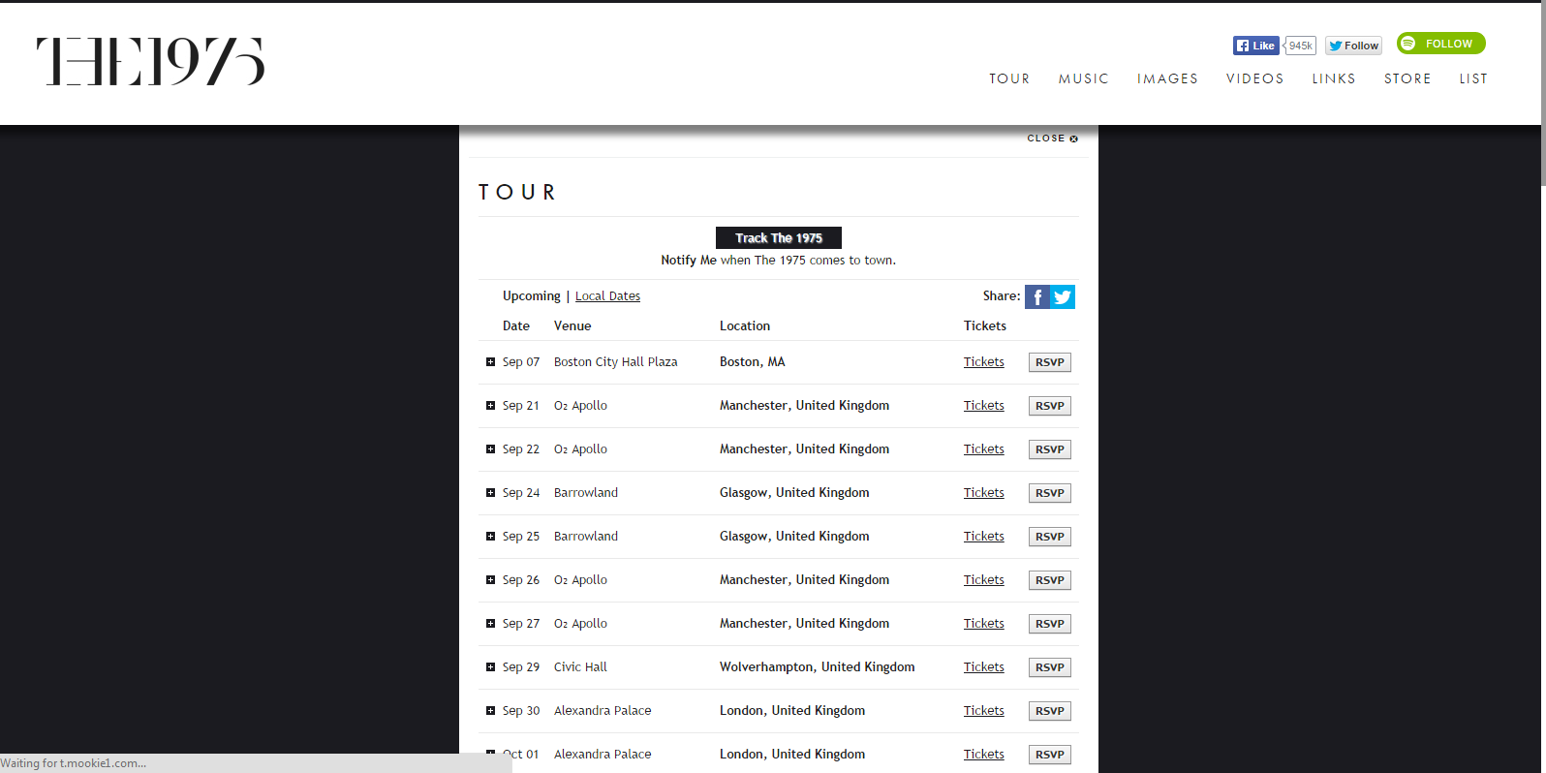
The 1975 – Subsequent page (Tour)
- The “Tours” page has been included in the site to give the audience information on when and where the band is playing and offers them a chance to buy tickets and share the tour dates on websites such as Facebook and Twitter. This connotes how the band make an effort to connect with their fans and are eager to get them to attend the gigs. Similar to the homepage the tours page is well integrated with social media sites as it has links to share the tour dates on other website like Twitter. This has been done to appeal to the target audience as they would be young (aged 15-24) and the integration with these website would be useful and convenient to them.
- The tours page prolongs the viewer’s interest by offering them the chance to buy tickets to shows and a way of tracking the band and seeing where they currently are: the “Track the 1975” button. This page could be more effective in keeping the viewer interested by incorporating the use of images of live performance to go with the tour dates as the page is slightly bland. This could be improved as it is important to keep the audience engaged and interested in the website. This could be done by fulfilling the ideologies and interests of the audience: the audiences of indie bands are more in to the “Art” of the music than the commercial side of music. The homepage is effective in fulfilling the audience’s ideology as it incorporates Polaroid style photos which are conventional of “art” music. The Tours page could be improved by incorporating more of these conventions to fulfil and prolong the audience’s interests.
- The “Track the 1975” button specifically targets the audience by offering them the chance to track the band on tour. This engages the audience and keeps them up to date on the bands activity. It connotes that the band want to give the audience an insight to the band’s lifestyle and connect with them all individually.

The “share” buttons engage the audience by encouraging them to share the tour dates and the activity of the band on social media sites such as Facebook and Twitter. This is important to the audience as it gives them the opportunity to get involved with the band and publicise their attendance at gigs. The “Share” buttons also work as a marketing technique – they raise awareness for the band by advertising them on websites like Twitter and Facebook. This connotes that the band want to reach out to new people to keep their audience growing and interested.

The “RSVP” button engages the viewer by getting them to confirm their attendance at the gigs. This is effective as it creates a sense of community and gives the audience an idea of how many people are attending. This is effective as it gets the audience involved. The “RSVP” button also connotes that the band like to feel connected to their audience as it offers them the chance to confirm their attendance and create a sense of community. The sense of community connoted would enhance the experience of going to one of the band’s live shows as each individual audience member would feel connected to the band.

- All of the text on the Tours page targets the audience as it gives them information on when and where the band is performing and engages them by encouraging them to share the tour dates on social networking sites and confirm their attendance at gigs. This connotes that the band want the audience to get involved and promote the band on various sites, the intention of the text on the tours page is to encourage sharing to promote the band and grow their audience. The text on the page is specific to a younger (15-24 years) audience as it is again centred around social media and sharing on external websites. The younger audience would like this feature as they would have accounts on these sites and would share links to the website. Therefore the text is specific to the younger audience. The text also targets the audience as it encourages them to buy tickets to the shows, this connotes that the band want their fans to attend the gigs and make money out of ticket sales.
- There are no moving images on the tours page as it mainly centres on information. The page is still effective in completing its purpose but it could be improved by adding images to make it not simply text. This would appeal to the target audience more as fans of the Indie genre would be more interested in the “Art” of music rather than the commercial side, so a page that is more centred around photos and the actual music would appeal to the specific audience more effectively and fulfil their ideologies.

The 1975 – Overall Analysis
- The overall message being delivered through the website is that “The 1975” are a very slick and conventional indie rock band. The conventions of an indie band are extravagance and high energy performance which are both connoted on the website through images of performance and extravagant lifestyle choices, for example: there is a picture of the band boarding a private jet on the homepage, this connotes that they make a lot of money and are not modest of it. This appeals to the specific audience as they would be aspirers - people with a want of a better life – this image, as pretentious as it may be, gives the audience something to aspire to. The common convention of high energy performance is connoted through frequent images of the band (mainly the singer Matthew Healy) performing. There are images of the band singing and playing their instruments signifying that they are all consumed by and devoted to the performance. This appeals to the target audience as they would aspire to be in the same position of great success as the band.
- The website effectively engages and attracts a modern audience by being very well integrated with other sites such as Facebook, Twitter, Instagram and Spotify. The website offers the audience an insight and involvement in the band’s lifestyle by sharing the band members’ posts on social networking sites. This integration with new media connotes that the band are very up to date and are aiming to attract and engage a modern audience. The audience is also frequently encouraged to share the website and follow the band on websites such as Spotify to create a heightened awareness for the band and grow their audience.
- The website has challenged conventional methods of advertising by hiding adverts for singles and EPs with the photos from social networking sites; this connotes that the audience are being let in on “the secret of the 1975,” this would appeal to the aspiring audience as it would connote that the adverts are secretive and premium – for a “important” people. This would give the target audience a sense of achievement as they are aspiring people – it connotes success and importance. This would make the viewer more prone to impulse buying as the “secretive” connotations of the advertising would give the audience a heightened sense of importance. The presence of new media is very prominent creating a high appeal to the younger (15-24 years old) audience. New media is also very useful as it is capable of spreading information very quickly; the website being well integrated with such sites would create a higher awareness for the band and continue to build their fan base – it is a very effective campaign.
- The website has been effective in targeting a specific audience (aspiring people of both genders aged 15-24) as it has used links and integration with new media sites such as Twitter and Facebook to attract a younger audience who would like the layout and integration involved in the website. According to Maslow’s Hierarchy of Needs the website offers self-esteem a feeling of achievement and actualisation. The website has also been effective in targeting fans of the Indie genre as it fulfils their ideologies of the importance of the “Art” side of the music over the commercial side of the music. The website fulfils these ideologies with the Polaroid style photos on the homepage that are comparable to “Hipster” and retro art photos that are reminiscent of the 70s and 80s. This creates a link between Art and Music effectively fulfilling the values and ideologies of the Indie audience.
- The values of the institution are that connecting with the audience is important and giving them an insight into the band’s lifestyle is also important and should be a large feature of the website. This is important as it would connote that the band isn’t unattainable and that they’re real people. It appeals to the aspiring target audience as it would signify that to be success like that of The 1975 isn’t out of reach for ordinary people. The attitudes connoted are very “rock n roll,” the extravagance and high energy is often signified through pictures on the homepage of the website. The beliefs connoted through the website are that the “Art” of music is very important and the live performance should be a big feature of the website. These beliefs are connoted through the retro style images of energetic live performance on the homepage. It is also connoted that the band making a connection with the audience is important due to the very effective integration with social media sites and the constant attempts to get fans involved – such as the links to share the website on sites like Facebook and Twitter and features of the website such as the “Track The 1975” button. This is also achieved by getting them to follow the band on various sites such as Facebook, Twitter, Instagram, Spotify and SoundCloud.
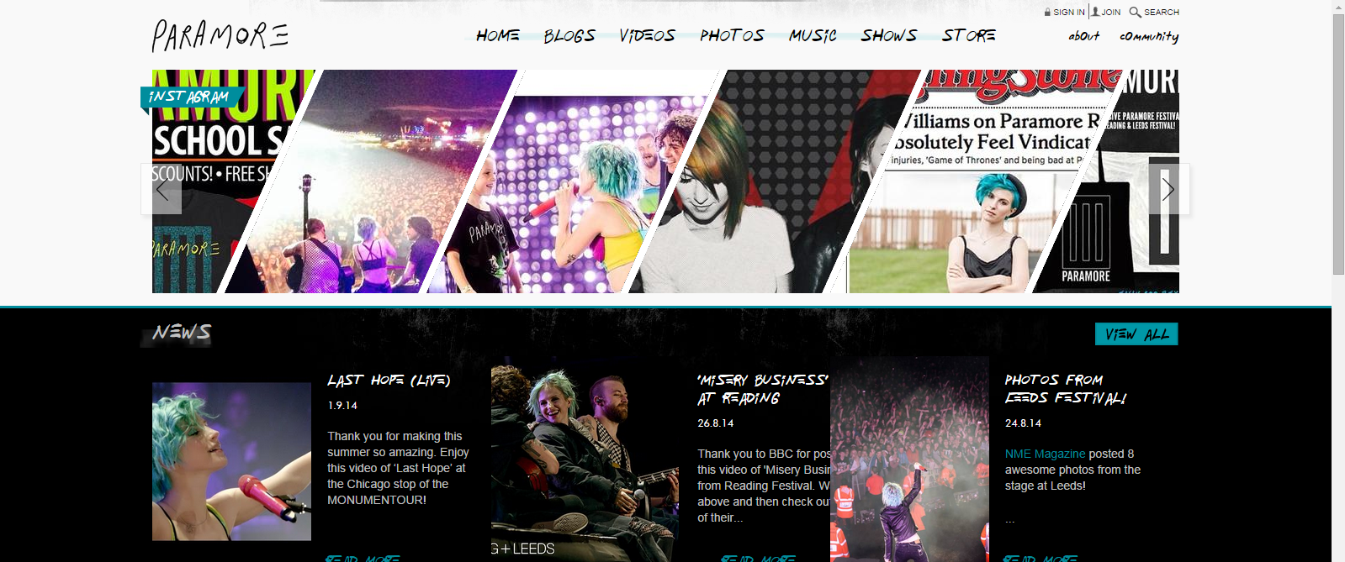
Paramore – Homepage

- The target audience for this website is working/middle class young girls aged 11-24. The website is more aimed at females due to the brighter and more vibrant colours used on the homepage, for example: the photos are in colour which connotes a happier and livelier attitude unlike that of The 1975. The website would be aimed at a younger audience due to the integration with new media – for example the first thing on the homepage is and Instagram feed that is integrated with the band’s Instagram account and also that of lead singer Hayley Williams, this connotes that the band like their audience to be up to date with what they’re doing therefore creating a stronger connection with their audience. The font used on the banner of the page is very scruffy and made to look like handwriting connoting that a page is like a blog or diary, this effectively connects with the target audience as it signifies that the information the website contains is personal to the band members (as the contents of a diary would be personal) and would be relatable as a lot of the specific target audience may keep a diary – the handwriting on the homepage could be their own. According to Maslow’s hierarchy of needs: the young female audience would be motivated by the way the homepage fulfils their basic needs and ideology of self-actualisation – it fulfils their creativity and builds their confidence.
- The homepage immediately grabs the attention of the audience by being very colourful and vibrant, the photos such as on the Instagram feed are in colour unlike the photos on the website for The 1975, this connotes that Paramore are more free-spirited and lively which is conventional of the punk/rock genre. It gives many different links to YouTube videos, social networking accounts and articles about the band – for example Hayley Williams’ recent interview with “Rolling Stone” magazine. This connotes that the band like their audience to be up to date with what they’re doing and actively encourage them to read articles on them and follow them on sites such as Instagram. This is important to the young target audience as they are more likely to want to follow the band on various social networking sites and be more obsessive over the band – they are explorers: people who seek individualism and something new.
- The website immediately establishes the genre of punk/rock through the links to YouTube videos of the band performing at places like the Reading Festival and interviews with prestigious rock magazines such as “Rolling Stone.” This connotes that the band want to stay true to conventions of the genre such as enjoying live performance and avoiding over production. The website contains many pictures of live performance like the website for The 1975, which connotes that they enjoy being on stage, but it is less conventional: the pictures and colour scheme of the website are much more vibrant and cheerful (brighter colours such as red, blue and purple as opposed to black, white and grey) which is not a convention of rock music which would usually incorporate darker colours such as black and white. The homepage is more true to Punk and Funk conventions as it incorporates lighter colours and less slick and modern text which connotes a more laid back attitude. These punk conventions are comparable to that on the websites of bands such as Green Day which uses a predominantly green and purple colour scheme and Red Hot Chili Peppers which incorporates a multi coloured colour scheme.
- The marketing strategies used on the website are on the Music page on which there are links to iTunes and Spotify by which the audience are encouraged to buy the band’s EPs and Albums their music is promoted commercially. The fact that the band promotes Spotify signifies they are in favour of individual music sites and encourage streaming their music, this connotes that they are a very modern band who accept new media and allow people to listen to their music for free, contrary to bands such as AC/DC who don’t allow their music to be streamed via Spotify. There is also a Store page when the audience are offered the chance to buy merchandise and CDs, this would fulfil the audience’s ideologies and needs as at a younger age they would be more materialistic and more likely to buy t-shirts and other merchandise. This connotes that the band want to make money as they put their music across commercially encouraging people to spend money. The homepage relies on making a connection with the audience to encourage them to buy albums and merchandise. This is connoted by the diary style of the homepage that is intended to make a personal connection with audience members, if individual audience members feel connected to the band they are more likely to spend money on music or merchandise. This also connotes the band want to make money as they often advertise merchandise on their website.
- The website is easy to navigate as everything is clearly labelled and pictured. All the news is grouped together for example; all aspects of the website are clearly separated and well integrated. These features are specific to the target audience as they make the website more logical and simple. The banner is the main way of navigating the website which is a conventional feature of music websites in general, the header also includes a login and community page to which the audience can sign up to, and this acts as a sort of social network which would attract the young target audience due to its relevance to new media. It would also fulfil an “explorer” audience’s ideology of something new and fulfil their basic need for self-esteem and friendship (according to Maslow’s Hierarchy of Needs).
- The very colourful and picture based nature of the website immediately draws in the audience and connotes a lively and happy attitude towards music. This is unconventional of the rock and punk genres as “happy” is not a connotation conveyed by either. The way the website draws the audience in is conventional of a website belonging to a pop artist such as McFly. This connotes that Paramore want to appeal to a mainstream audience, these features don’t fulfil the ideology of a punk/rock audience who wouldn’t be in favour of the “mainstream.” The website offers a very personal experience due to the fans being able to log in and be part of a “community.” These features connote that Paramore care about their audience and encourage them to sign up to the website. The website is friendlier than that of the 1975 due to its colourful and happy connotations whereas that of the 1975 is not colourful and connotes a grunge or “emo” vibe, so it appeals to a different, predominantly “tween” female audience.
- The website often includes social media by placing links to websites such as Facebook, Twitter and Spotify below the header of the website. Links to free music sharing websites such as Spotify denote that Paramore share their music on the sites and that they actively encourage their audience to stream their music, this connotes that they are up to date with new media and music sharing and aren’t afraid to share their music for free. The common use of sites such as Twitter and Instagram signifies that the band is very up to date and frequently use the websites to connect with their audience and connotes that they want to connect to each audience member individually and have a friendly attitude towards them. These features appeal to the young target audience as they would like how the website is well integrated with other sites they use.

- The text on the homepage targets the audience by being made to look like handwriting which connotes a carefree attitude that would appeal to the target audience as they would like the attitudes connoted and be influenced by them. The text being like handwriting also connotes that the website has been made to look like a diary or scrapbook: these things are personal and in a metaphorical sense the website has been made to seem like these things to connote that the band are sharing personal things with their audience like pictures from their experiences on tour. This makes the website more relatable for a “tween” female target audience as the handwriting on the homepage could be their own. These features connote that the band aims to connect with each individual audience member on a personal level.
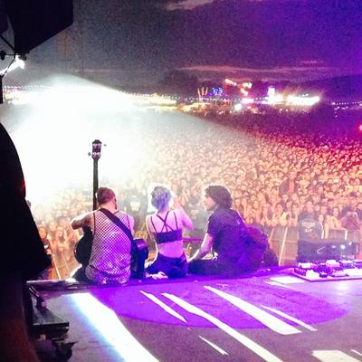
- The images on the homepage are conventional of the rock genre as they are of live performance, for example on the homepage there are frequent images of the band’s recent performance at Reading Festival in which the singer Hayley Williams, guitarist Taylor York and bassist Jeremy Davis are smiling, this connotes that they enjoy live performance and aim to fulfil their audience’s expectations. The picture of the band sitting together connotes their togetherness as a band and how they are comfortable and feel at home on stage.

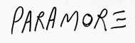
The colours and texts are not conventional of the rock genre as they are not as slick and more colourful and vibrant than that on the 1975 website. For example the text is in the style of handwriting which is more conventional punk music, this is connoted through the band’s logo and text on the banner. The website is recognisable as a the website of a band but the genre is less clear – through their website Paramore are conventionally represented as more of a pop band. The features of the website are more conventional of a pop band and cater to a modern audience, these conventions are not reflected in their music however.
- The news and Instagram feeds on the homepage periodically move to show the different current stories, this is more conventional of a pop band than rock. This targets the specific audience by encouraging them to use social networking sites such as Twitter and Instagram to follow Paramore, this signifies that Paramore want their fans to hear and see these interviews; this connotes their belief that connecting with their audience on a personal level is important. This would fulfil the audience’s basic need for friendship, according to Maslow’s hierarchy of needs. The pop conventions of Paramore’s website connote that they are trying to appeal to a more mainstream audience as pop is a largely mainstream genre, hence why it is called “popular” music. These conventions could be slightly misleading as Paramore’s music is largely Punk/Rock, the audience that these genres appeal to aren’t conventionally mainstream, the ideologies connoted through these genres are that being individual is important. These Punk/Rock conventions are contradicted by Paramore trying to appeal to a mainstream pop audience.

Paramore - Subsequent Page (Blog)
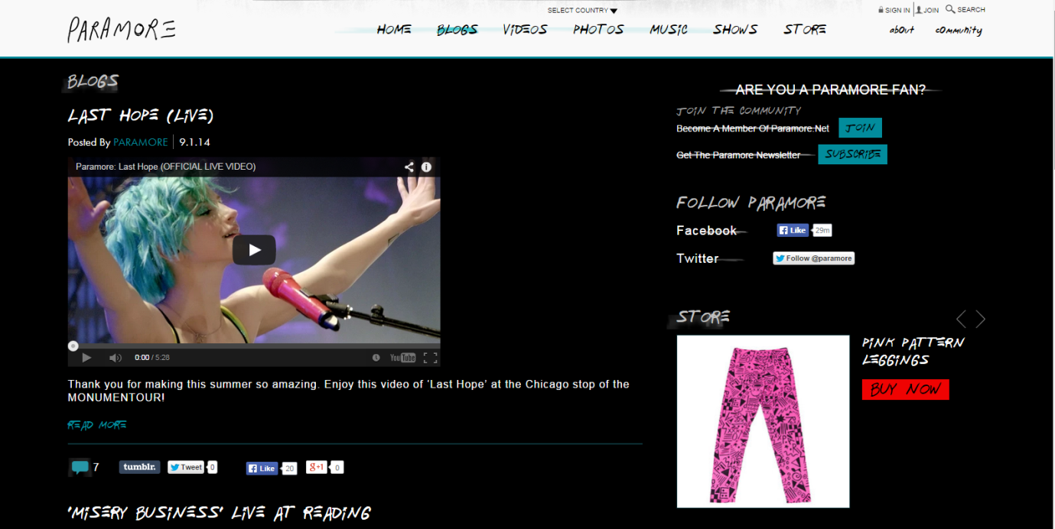
- The “Blogs” page has been included in the website to give the audience an insight into current news stories about the band, this connotes that the band want their audience to be up to date with what they’re doing and connect to each audience member individually and encourage their audience to buy merchandise and music, for example: the advert encouraging the audience to buy “Pink Pattern Leggings.” This appeals to the younger (11-24) “Tween” female audience as the product advertised is for females, also as a younger audience would be more prone to being drawn in by materialistic things. This advertising being targeting at a younger audience signifies that the band targets a younger audience who are easily persuaded to make money. It connotes that the band are very money orientated. It seems to mainly be an advertising page that encourages the audience to visit sites like Facebook and Twitter to follow the band. For example the “Are you a Paramore fan?” and “Follow Paramore” sections of the page encourage the audience to follow the band. This also connotes that Paramore are up to date with social networking sites want to connect with their audience on a personal level due to the integration with social media websites.
- The blogs page is important to keeping the audience engaged and interested as it has many links to sites such as YouTube and the merchandise store where there is more content for the audience. This connotes that Paramore want to keep their audience interested and engaged. The blogs page encourages the audience to follow the band on Twitter and like their page on Facebook as it would prolong their interest and engage them. If the audience were to follow the band on these sites the most recent posts would come up on their timelines. This connotes that Paramore want to keep their audience engaged and up to date. The audience are encouraged to like the band’s pages as it would promote the band on these sites and therefore build their audience. This connotes that Paramore are trying to appeal to a wider audience to build their audience and use their pre-existing audience in an attempt to do so.
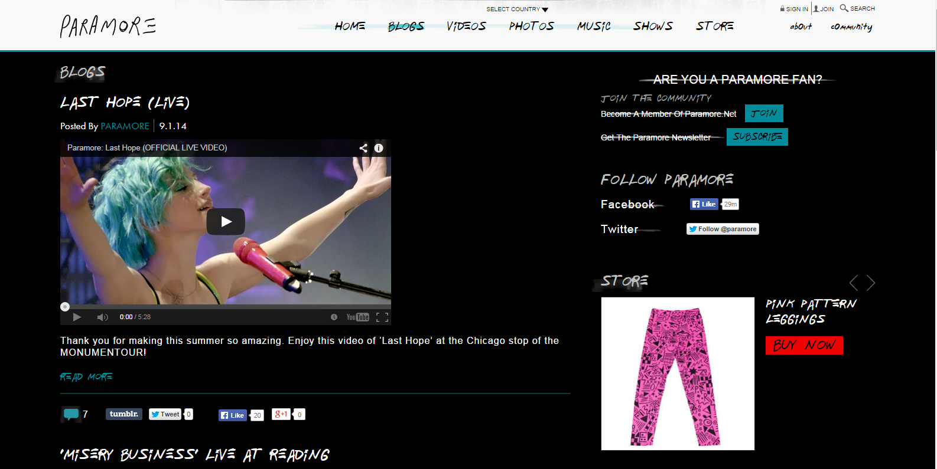
- The “Are you a Paramore fan?” section of the page targets the audience by encouraging them to join the Community page and sign up to the newsletter. It gives the audience involvement with the band and a chance of insight into the bands activity. The section of the page describes itself as a “Community.” This connotes that Paramore want to create a sense of community among the audience.
This part of the page is integrated with new media sites Facebook and Twitter. It encourages the audience to follow the band on the various social networking sites. It connotes that they are up to date with new media. This connotes that Paramore want to keep their audience engaged. This feature connotes that Paramore want to build their audience through increasing their amount of likes or follows on Facebook and Twitter.

The “Store” section advertises merchandise and encourages the audience to visit the full store by giving an example of the merchandise. It is an effective way of marketing as it targets the young female audience who are more inclined to pay for merchandise, this connotes that Paramore want to make money, they do this by advertising to a younger audience who are more likely to want and buy material things. This feature overall connotes that the band are money orientated.

- The text targets the audience effectively by being personal – for example the caption for a YouTube video is: “Thank you for making this summer so amazing,” making it seem as if it’s trying to speak to each individual audience member. This connotes how Paramore appreciate their following and their audience and aim to fulfil their expectations. All of the text on the Blog page targets the audience it gives them information on current news stories involving Paramore and encourages the audience to follow the band on different social networks. This connotes that the band want the audience to promote the band to grow their audience. The text on the page is specific to the female “tween” (11-24 years) audience as it based around social networks and advertising merchandise made for females. The younger audience would like this feature as they would have access to merchandise and get the opportunity to be part of a “community.”
- There is no moving image on the blogs page unlike the homepage. The page is based around advertising and connotes that Paramore are money orientated and try to promote themselves and build their audience. Whilst there is no moving image on the page it is still specific to the target audience as its main features are social networking and advertisement, it appeals to the “Tween” target audience as the products advertised are made to be specific to that target audience. The page could be improved by adding more colour and images like that of the homepages of bands like Green Day and Kasabian to make it conventional of the Punk genre.

Paramore – Overall Analysis
- The overall message being connoted by the website is that Paramore are very audience orientated, they believe that it is important to get their target audience - “Explorer” females ages 11-14 searching for “something new” - involved and keep them engaged. The frequent photos of live performance in places such as Reading Festival connote that they really enjoy playing live and are high energy performers. This also connotes that they like to stay true to conventions of Punk/Rock as live performance is a common convention of the genres. Overall though, the message being connoted is that Paramore are not conventional of a Punk/Rock band, the website uses a bright and vibrant colour scheme (blue, purple and pink) which is more conventional of a Pop artist, this connotes that Paramore want to appeal to a mainstream audience and aim to do this by promoting themselves through social media sites such as Facebook and Twitter. The Pop connotations of the website, such as the “community” and bright colour scheme, are slightly contradictory of the style of the band’s music, which connotes that Paramore want to make Punk/Rock more mainstream.
- The website effectively engages and attracts a modern audience by being very well integrated with social media sites such as Facebook, Twitter and Instagram. This connotes that Paramore want to appeal to a younger and wider audience by being up to date with technology and social networking. The integration with new media connotes that Paramore are trying to cater to a modern audience. The vibrant colour scheme of the website attracts fans of pop music and encourages them to become part of Paramore’s audience. It also connotes that Paramore aim to widen the audience for their genre of music.
- The website has effectively challenged conventional advertising methods used in the music industry by placing adverts among new media links to make them seem less prominent. The adverts are aimed at a specific target audience: females aged 11-24, “tweens.” Audience members at this age are more impressionable and more likely to want material things such as “Pink Pattern Leggings,” therefore the adverts challenge conventional methods of advertising as they are very specific in their target audience. The adverts connote that Paramore are money orientated as the adverts are aimed at the specific audience most likely to want merchandise.
- The website has been effective in targeting a specific audience (female “explorers” aged 11-24) as it has used links and integration with new media sites such as Twitter and Facebook to attract a younger audience who would like the integration with social networking included in the website. The website offers self-esteem a feeling of family and acceptance and therefore fulfils basic needs of the audience (Maslow’s Hierarchy of Needs). The website has been effective in targeting fans of the Punk genre as it incorporates a bright colour scheme with colours such as purple and pink which are conventional of the genre. It has been less effective in appealing to fans of Rock as it is unconventional of a Rock band: it lacks the slick layout and text like that on The 1975’s website. The website fulfils the needs of the “Tween audience as it offers a “Community” and a feeling of family. This connotes that Paramore aim to keep their target audience engaged and interested.

- The values of the institution are that connecting with and keeping the audience engaged and interested is important and encouraging the audience to follow and promote the band on social networks is also important. It is connoted that it is important to keep the female “tween”-teen audience engaged by giving them role models to aspire to. For example Hayley Williams isn’t overly sexualised in any images on the website, she never wears any overly revealing clothes, this connotes that she is a good influence and a good role model. The attitudes connoted are that the band is money orientated due to the advertisements being aimed at a younger target audience who are more likely to spend money on merchandise. It is connoted that the band believe that making a connection with the audience is important due to the very effective integration with social media sites and the constant attempts to get fans involved by getting them to follow the band on various sites such as Facebook, Twitter and Instagram, for example the “Follow Paramore” and “Are you a Paramore fan?” sections. It is also connoted that Paramore aim to appeal to a wider mainstream audience through the pop conventions of their website such as the “Community” page and bright colour scheme.

